**LABORATORY MANUAL**

**SOFTWARE ARCHITECTURE AND DESIGN PATTERNS LAB**

*for*

**IV Year I Sem. B.Tech. (CSE)**

Academic Year 2020-21

Prepared by

*Assoc.Professor Assistant professor*



**Department of Computer Science and Engineering**



**Contents:**

|  |  |  |
| --- | --- | --- |
| **S.No** | ***Index*** | **Page No** |
| 1 | *Vision, Mission* | *ii* |
| 2 | *PEOs and POs* | *iii-iv* |
| 3 | *Preface* | *v* |
| 4 | *Lab objectives & Guidelines to the students* | *vi* |
| 5 | *University Syllabus* | *vii* |
| 6 | *List of Experiments to be conducted for this semester* | *viii-ix* |
| 7 | **Experiments** |  |
| 8 | **Experiment 1:**   1. **Tool Presentation:** Presentation of the Project: Weather Mapping System. 2. **Use Case View:** Design of the Use Case View. Risk Analysis. 3. **Logical View:** Design of the Logical View of the Weather Mapping System (WMS). |  |
| 9 | **Experiment 2:**   1. **Integrating Patterns in the Architecture:** Integration of selected architectural and design patterns in the logical view obtained previously. 2. **Implementation, Process, and Deployment Views:** Design of the implementation, process, and deployment views for the Weather Mapping System. 3. **Component and Interprocess Communication Design:** Generation from the previous architecture design of CORBA Interfaces and Components Definitions. |  |
| 10 | **Experiment 3:**  **Implementation of WMS:** Implementation of the Weather Mapping System (Java & C++), with a particular emphasis on the Interprocess communication mechanism and the software components identified. |  |
| 11 | **Experiment 4:**   1. Use case Diagram for Librarian Scenario 2. Using UML design Abstract factory design pattern |  |
| 12 | **Experiment 5:**   1. Using UML design Adapter-class Design pattern 2. Using UML design Adapter-object Design pattern |  |
| 13 | **Experiment 6:**   1. Using UML design Strategy Design pattern 2. Using UML design Builder Design pattern |  |
| 14 | **Experiment 7:**   1. Using UML design Bridge Design pattern 2. Using UML design Decorator Design pattern |  |
| 15 | **Experiment 8:**   1. User gives a print command from a word document. Design to represent this chain of responsibility Design pattern 2. Design a Flyweight Design pattern |  |
| 16 | **Experiment 9:**   1. Using UML design Facade Design pattern 2. Using UML design Iterator Design pattern |  |
| 17 | **Experiment 10:**  Using UML design Mediator Design pattern |  |
| 18 | **Experiment 11:**  Using UML design Proxy Design pattern  Using UML design Visitor Design pattern |  |

**Vision & Mission**

**Vision of the Institute:**

Confect as a premier institute for professional education by creating technocrats who can address the society`s needs through inventions and innovations.

**Mission of the Institute:**

1. Partake in the national growth of technological, industrial arena with societal responsibilities.

2. Provide an environment that promotes productive research.

3. Meet stakeholders expectations through continued and sustained quality improvements.

**Vision of the Program:**

Build a learning environment that enhances creativity, social awareness and leadership skills for total personality development.

**Mission of the Program:**

To provide the learner with an exposure to emerging technologies by providing hands-on experience making them creative and research oriented professionals with values, Leadership qualities and zeal to serve the society.

**Program Educational Objectives:**

This education is meant to prepare our students to thrive and to lead. In their careers, our graduates

|  |  |
| --- | --- |
| P1 | Graduates will be able to analyze, design, and develop advanced computer applications to provide solution to real world problems. |
| P2 | Graduates are well trained, confident, research oriented and industry ready professionals who are intellectual, ethical and socially committed. |
| P3 | Graduates will have the technical, communication skills and character that will prepare them for technical and leadership roles. |

**Program Learning Outcomes:**

Students in the Electronics and Communication Engineering program should, at the time of their graduation, be in possession of:

1. **Engineering Knowledge:** Apply knowledge of mathematics, science, engineering fundamentals and an engineering specialization to the solution of complex engineering problems.
2. **Problem Analysis:** Identify, formulate, research literature and analyze complex engineering problems reaching substantiated conclusions using first principles of mathematics, natural sciences and engineering sciences.
3. **Design/ Development of Solutions:** Design solutions for complex engineering problems and design system components or processes that meet specified needs with appropriate consideration for public health and safety, cultural, societal and environmental considerations.
4. **Conduct investigations of complex problems** using research based knowledge and research methods including design of experiments, analysis and interpretation of data and synthesis of information to provide valid conclusions.
5. **Modern Tool Usage:** Create, select and apply appropriate techniques, resources and modern engineering and IT tools including prediction and modelling to complex engineering activities with an under- standing of the limitations.
6. **The Engineer and Society:** Apply reasoning informed by contextual knowledge to assess societal, health, safety, legal and cultural issues and the consequent responsibilities relevant to professional engineering practice.
7. **Environment and Sustainability:** Understand the impact of professional engineering solutions in societal and environmental contexts and demonstrate knowledge of and need for sustainable development.
8. **Ethics:** Apply ethical principles and commit to professional ethics and responsibilities and norms of engineering practice.
9. **Individual and Team Work:** Function effectively as an individual, and as a member or leader in diverse teams and in multidisciplinary settings.
10. **Communication:** Communicate effectively on complex engineering activities with the engineering community and with society at large, such as being able to comprehend and write effective reports and design documentation, make effective presentations and give and exclusive clear instructions.
11. **Life-long Learning:** Recognize the need for and have the preparation and ability to engage in independent and life- long learning in the broadest context of technological change.
12. **Project Management and Finance:** Demonstrate knowledge and understanding of engineering and management principles and apply these to one’s own work, as a member and leader in a team, to manage projects and in multidisciplinary environments.

**Program Specific Outcomes**

1. **Mobile & Web Application Development**: Ability to develop mobile & web applications using J2EE, Android and J2ME.
2. **Cloud Services**: To deploy virtualized and cloud based services in the organization

**Preface:**

The course project is divided in 6 small components that will be performed during the different lab sessions; there are, in principle, 7 lab sessions. The project consists of the design and implementation of the software architecture of a Weather Mapping System (WMS).

Implementation will take place both in Java and C++ (combination of both languages).Each lab assignment consists of a theoretical part and a practical part, which are defined in specific lab assignment statements that are posted at least one or two weeks before the session.

Lab reports should include:

* The answers to the questions included in the assignment statement. The answers should motivate briefly your design choices.
* The printout of the diagrams and related documents (e.g. class, use cases, operations descriptions etc.) produced using Rational Rose.

Although, as per the syllabus, study of Software Architecture and Design Patterns is prescribed, we have made the efforts to cover various aspects of Software Testing covering different testing types

Students are advised to thoroughly go through this manual rather than only topics mentioned in the syllabus as practical aspects are the key to understanding and conceptual visualization of theoretical aspects covered in the books.

Good Luck for your Enjoyable Laboratory Sessions

The Software Architecture And Design Patterns Lab will facilitate the students to develop a preliminary yet practical understanding of software development process and using UML diagrams.

**Authors**

**LAB OBJECTIVES:**

This course will enable the students to

* Design and implementation of the software architecture of a Weather Mapping System (WMS)
* To understand interrelationships, principles and guidelines governing architecture and evolution over time.
* To understand various architectural styles of software systems.
* To understand design patterns and their underlying object oriented concepts.
* To understand implementation of design patterns and providing solutions to real world software design problems.
* To understand patterns with each other and understanding the consequences of combining patterns on the overall quality of a system.

**LAB OUTCOMES :**

After the completion of this course student will be able to

* Understand the Case studies and design the Model.
* Understand how design patterns solve design problems.
* Develop design solutions using creational patterns.
* Construct design solutions by using structural and behavioral patterns

**RECOMMENDED SYSTEMS / SOFTWARE REQUIREMENTS :**

* Intel based desktop PC with P-IV or above, minimum of 166MHZ or faster processor with at least 512MB RAM and 10GB free disk space.
* Windows OS with MS Office Package. Recommended.
* Rational Rose Software

**Guidelines to the Students**

* Be regular to the Lab. After entering into the Lab, Sign in the Log-register.
* Students should come with observation and record.
* Lab attendance will play a part of the internal assessment marks
* The students should come to the lab with a prior preparation to complete the programs within time.
* Students should get their observation books corrected before leaving the lab and should submit the records in next lab session.
* Follow the dress-code while coming to the Lab. Strict discipline should be maintained inside the laboratory.
* At the mid and end of the semester, lab exams will be conducted.
* Shut down the system properly, turn-off the monitor, Arrange the chair properly and then leave. Handle the systems carefully.



**JAHAWARLAL NEHRU TECHNOLOGICAL UNIVERSITY KAKINADA**

**Academic Year 2018-19**

**IV Year B.Tech - I Sem.**

**Software Architecture and Design Patterns Lab**

**List of experiments as per the university**

**No. of Credits: 2**

**PROGRAMS LIST:**

**1. Tool Presentation:** Presentation of the Project: Weather Mapping System.

**2. Use Case View:** Design of the Use Case View. Risk Analysis.

**3: Logical View:** Design of the Logical View of the Weather Mapping System (WMS).

**4: Integrating Patterns in the Architecture:** Integration of selected architectural and design patterns in the logical view obtained previously.

5**: Implementation, Process, and Deployment Views:** Design of the implementation, process, and deployment views for the Weather Mapping System.

**6: Component and Interprocess Communication Design:** Generation from the previous architecture design of CORBA Interfaces and Components Definitions.

**7: Implementation of WMS:** Implementation of the Weather Mapping System (Java & C++), with a particular emphasis on the Interprocess communication mechanism and the software components identified.

**Design Patterns Lab**

**S. No Programs**

1. Use case Diagram for Librarian Scenario

2. Using UML design Abstract factory design pattern

3. Using UML design Adapter-class Design pattern

4. Using UML design Adapter-object Design pattern

5. Using UML design Strategy Design pattern

6. Using UML design Builder Design pattern

7. Using UML design Bridge Design pattern

8. Using UML design Decorator Design pattern

9. User gives a print command from a word document. Design to represent this chain of responsibility Design pattern

10. Design a Flyweight Design pattern

11. Using UML design Facade Design pattern

12. Using UML design Iterator Design pattern

13. Using UML design Mediator Design pattern

14. Using UML design Proxy Design pattern

15. Using UML design Visitor Design pattern



**Academic Year 2018-19**

**IV Year B.Tech - I SEM**

**Software Architecture and Design Patterns Lab**

**List of experiments to be conducted for this semester**

**No. of Credits: 2**

**Experiment 1:**

1. **Tool Presentation:** Presentation of the Project: Weather Mapping System.
2. **Use Case View:** Design of the Use Case View. Risk Analysis.
3. **Logical View:** Design of the Logical View of the Weather Mapping System (WMS).

**Experiment 2:**

1. **Integrating Patterns in the Architecture:** Integration of selected architectural and design patterns in the logical view obtained previously.
2. **Implementation, Process, and Deployment Views:** Design of the implementation, process, and deployment views for the Weather Mapping System.
3. **Component and Interprocess Communication Design:** Generation from the previous architecture design of CORBA Interfaces and Components Definitions.

**Experiment 3:**

**Implementation of WMS:** Implementation of the Weather Mapping System (Java & C++), with a particular emphasis on the Interprocess communication mechanism and the software components identified.

**Experiment 4:**

1. Use case Diagram for Librarian Scenario
2. Using UML design Abstract factory design pattern

**Experiment 5:**

1. Using UML design Adapter-class Design pattern
2. Using UML design Adapter-object Design pattern

**Experiment 6:**

1. Using UML design Strategy Design pattern
2. Using UML design Builder Design pattern

**Experiment 7:**

1. Using UML design Bridge Design pattern
2. Using UML design Decorator Design pattern

**Experiment 8:**

User gives a print command from a word document. Design to represent this chain of responsibility Design pattern

Design a Flyweight Design pattern

**Experiment 9:**

1. Using UML design Facade Design pattern
2. Using UML design Iterator Design pattern

**Experiment 10:**

Using UML design Mediator Design pattern

**Experiment 11:**

Using UML design Proxy Design pattern

**Experiment 12:**

Using UML design Visitor Design pattern

**Index**

|  |  |  |  |  |
| --- | --- | --- | --- | --- |
| **Prog No** | **Date of Completion** | **Name of Program/ Experiment** | **Marks/ Grade** | **Signature of Faculty** |
|  |  |  |  |  |
|  |  |  |  |  |
|  |  |  |  |  |
|  |  |  |  |  |
|  |  |  |  |  |
|  |  |  |  |  |
|  |  |  |  |  |
|  |  |  |  |  |
|  |  |  |  |  |
|  |  |  |  |  |
|  |  |  |  |  |
|  |  |  |  |  |
|  |  |  |  |  |
|  |  |  |  |  |
|  |  |  |  |  |
|  |  |  |  |  |
|  |  |  |  |  |
|  |  |  |  |  |
|  |  |  |  |  |
|  |  |  |  |  |
|  |  |  |  |  |
|  |  |  |  |  |
|  |  |  |  |  |

**Summary of the Requirements for the Weather Mapping System (WMS)**

**System Overview**

A weather mapping system (WMS) is required to generate weather maps on a regular basis using data collected from remote, unattended weather stations and other data sources such as weather observers, balloons and satellite. Weather stations transmit their data to the area computer in response to a request from that machine. The area computer system validates the collected data and integrates the data from different sources.

The integrated data is archived and, using data from this archive and a digitized map database, a set of local weather maps is created. Maps may be printed for distribution on a special-purpose map printer or may be displayed in a number of different formats. Typically, the weather data collection system establishes a modem link with the weather station and requests transmission of the data. Then, the weather station sends a summary of the weather data that has been collected from the instruments (e.g. anemometer, barometer, ground thermometer) in the collection. The data sent to the weather data collection system are the maximum, minimum and average ground temperatures, the maximum, minimum and average air pressures, the maximum, minimum, and average wind speeds.

Weather stations are usually asked to report once per hour but this frequency may differ from one station to another and be modified in the future. Weather stations are also automatically monitored by the system, for start-up, shutdown, and for instrument testing and calibration. Another function carried out by weather stations is pollution monitoring. More specifically, there is an air quality meter that computes the amount of various pollutants in the atmosphere collected from pollution monitoring instruments (e.g. No meter, Smoke meter and Benzene meter). The pollution readings are transmitted at the same time as the weather data. The pollution data collected are NO, smoke and benzene rates.

**Product Features**

WMS provides a range of map processing operations (e.g. two-dimensional and three dimensional mappings), weather data storage for the maps, and network access to the maps for remote viewers.

Its key marketing features are the following:

* + A user-friendly operator environment
  + The throughput of weather data acquisition is 50% higher than previous product
  + Maps display can be as fast as the maximum hardware speed
  + Is designed for easy upgrade to new platforms
  + Has open platform connectivity
  + Can be connected to peripherals, including printers and digital imagers.

A single control panel is provided with each WMS unit. Additional independent viewing stations are also available.

**The Future of WMS**

WMS must be designed to be extensible, maintainable, and portable. Its design must be flexible enough to accommodate certain expected changes. The product requirements may change somewhat during development and certainly will change over the lifetime of the product. The physical characteristics of the weather data acquisition instruments may change as new models are introduced.

As the processing power of the system increases, more and more work that was the responsibility of the users will shift to the system. Other product features will also likely change. The product needs to remain compatible with new or evolving standards for file formats and communication of weather information. In addition, the technology affecting the software components is likely to change over the lifetime of the system. WMS may have to be improved to handle upgrades to commercial components that are part of the product, and the target software environment is likely to change as upgrades are introduced.

**The Company**

The software company in charge of the development of the WMS has faced significant turnover of their skilled personnel in the last few years, mainly due to the competitive job market. Facing at the same time tight deadlines set by the customers to deliver useful business functionality; the company has decided to make use of significant third-party products and packages as an integral part of their application. However they will also maintain development and maintenance control of the mission-critical components of their applications.

**Experiment No-1 Date: / / 20**

**Aim : Weather Mapping System (WMS)**

1. **Tool Presentation:** Presentation of the Project: Weather Mapping System.

**Description**:

*ROSE = Rational Object Oriented Software Engineering*

A set of visual modeling tools for development of object oriented software is Rational Rose.

Visual Modeling is the process of graphical representation of picture or sculpture for the system to be developed:

* Presenting essential details
* Filtering out non-essential details
* Viewing the system from different perspectives

Rational Rose is a type of tool set produced and marketed by Rational Software Corporation. Rational Rose is commercial case-tool software. Rational Rose is an operational tool set and it is used for the Unified Modeling Language (UML). In UML there are different types of notations, allowing the specification of the artifacts of design from many different perspectives and for different objectives during the computer engineering life cycle. Most of the notations are directly supported through the Rose tool set.

**It supports two essential elements of modern software engineering:** component based development and controlled iterative development. Models created with Rational Rose can be visualized with several UML diagrams.

Rational Rose Views Related to the Software Development Life Cycle.

*Rational Rose models have these four views:*

* Use Case View
* Logical View
* Component View
* Deployment View

**1. B). Use Case View:** Design of the Use Case View. Risk Analysis.

**Description:**

***A. Use Case Modeling***

1. Identify the actors involved in this problem, create them and provide appropriate documentation using Rational Rose. The documentation for an actor is a brief description that should identify the role the actor plays while interacting with the system. (20%)

2. Evaluate the needs that must be addressed by the system, and based on this information, identify the use cases for this problem. Create the use cases and provide appropriate documentation using Rational Rose. The documentation for a use case is a brief description that states the purpose of the use case in few sentences, and gives high-level definition of the functionality provided by the use case. (20%)

3. Create the main use case diagram in Rational Rose, by putting together the use cases and actors identified previously. Complete the diagram by defining and creating appropriate relationships among the actors and use cases involved. (10%)

***B. Risk Analysis***

1. One of the most important risks that the development of the weather mapping system is facing is *Change management*; failure to handle properly for instance changes in the product requirements may lead to the overall project failure.

Identify using a cause-effect (sub) tree the risks hierarchy that may lead to the materialization of this risk. Describe these risks and corresponding reduction measures by providing a risk registry. (30%)

2. Not all use cases are architecturally significant. Only critical use cases that carry the most important risks, or the quality requirements or key functionalities are eligible for the architecture definition. One such use case encompasses functionality for collecting data from remote sources: we call it *Collect data*.

Based on the system requirements, motivate briefly how the *Collect data* use case relates to the *Change management* risk specified previously. Provide the flow of events for *Collect data* use case. The flow of events is a description of the events needed to accomplish the required behavior of the use case. The flow of events is written in terms of what the system should do, not how the system does it. Link the flow of events document to the use cases in your Rose model. (20%)

**Solution:**

***Actor documentation:***

1. The following actors may be identified from the requirements: Instrument, Weather Instrument, Pollution Instrument, Operator, Digitized map database and Consumer.

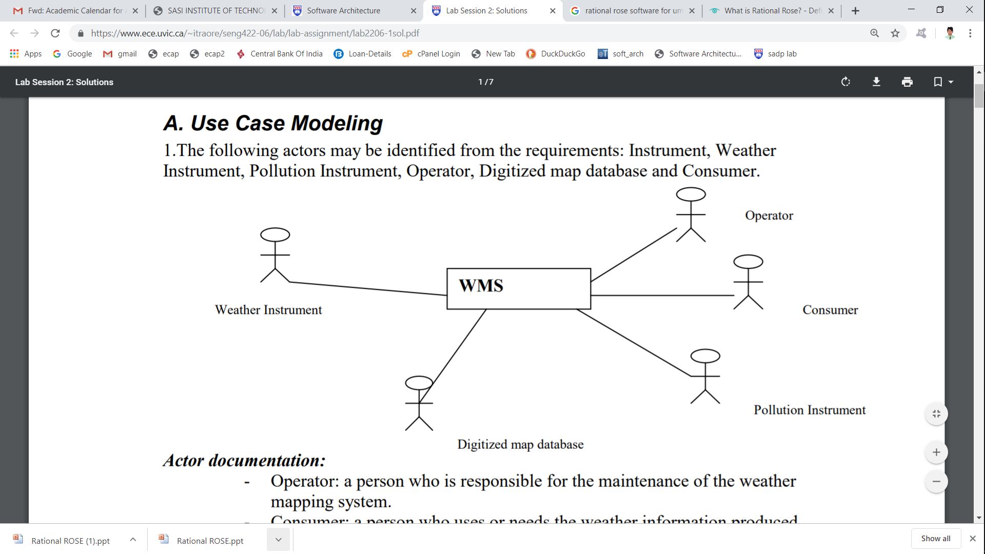

* + **Operator:** a person who is responsible for the maintenance of the weather mapping system.
  + **Consumer**: a person who uses or needs the weather information produced by the system.
  + **Weather Instrument:** weather sensors related to weather stations used to collect raw weather data.
  + **Pollution Instrument:** air data sensors used to collect air data for pollution monitoring.
  + **Instrument:** generalization of weather and pollution sensors.
  + **Digitized map database:** an existing database containing mapping information.

2. The following needs must be addressed by the system:

* + The Consumer actor needs to use the system to view or print weather maps.
  + Weather sources collect weather data and send them on request to the area computer.
  + The area computer validates, integrates and archives the weather data collected, and then processes weather maps.
  + The digitized map database provides the mapping information needed to process local weather maps.
  + The Operator actor manages and maintains the system.
  + The area computer monitors the weather sources, for start-up, shutdown, and for instrument testing and calibration.

***Needs:***

Based on these needs, the following use cases may be identified:

* + Startup
  + Shutdown
  + Collect data
  + Calibrate
  + Test
  + Validate
  + Integrate
  + Archive
  + Process map
  + Display
  + Print

You may identify different use cases (or the same use cases with different names). In all cases the sum of the use cases identified must cover all the key functionalities mentioned in the needs. That should appear through the documentation that you will provide.

***Use Case Documentation:***

The documentation provided for a use case consists of a brief description of the purpose of the use case in a few sentences. For instance, a brief description of the Collect data use case may be:

The operator or the system starts this use case. It consists of sending a request for data collection to the weather sources, which collect and summarize weather data from the instruments and send them to the area computer.

***Main Use Case Diagram for WMS***

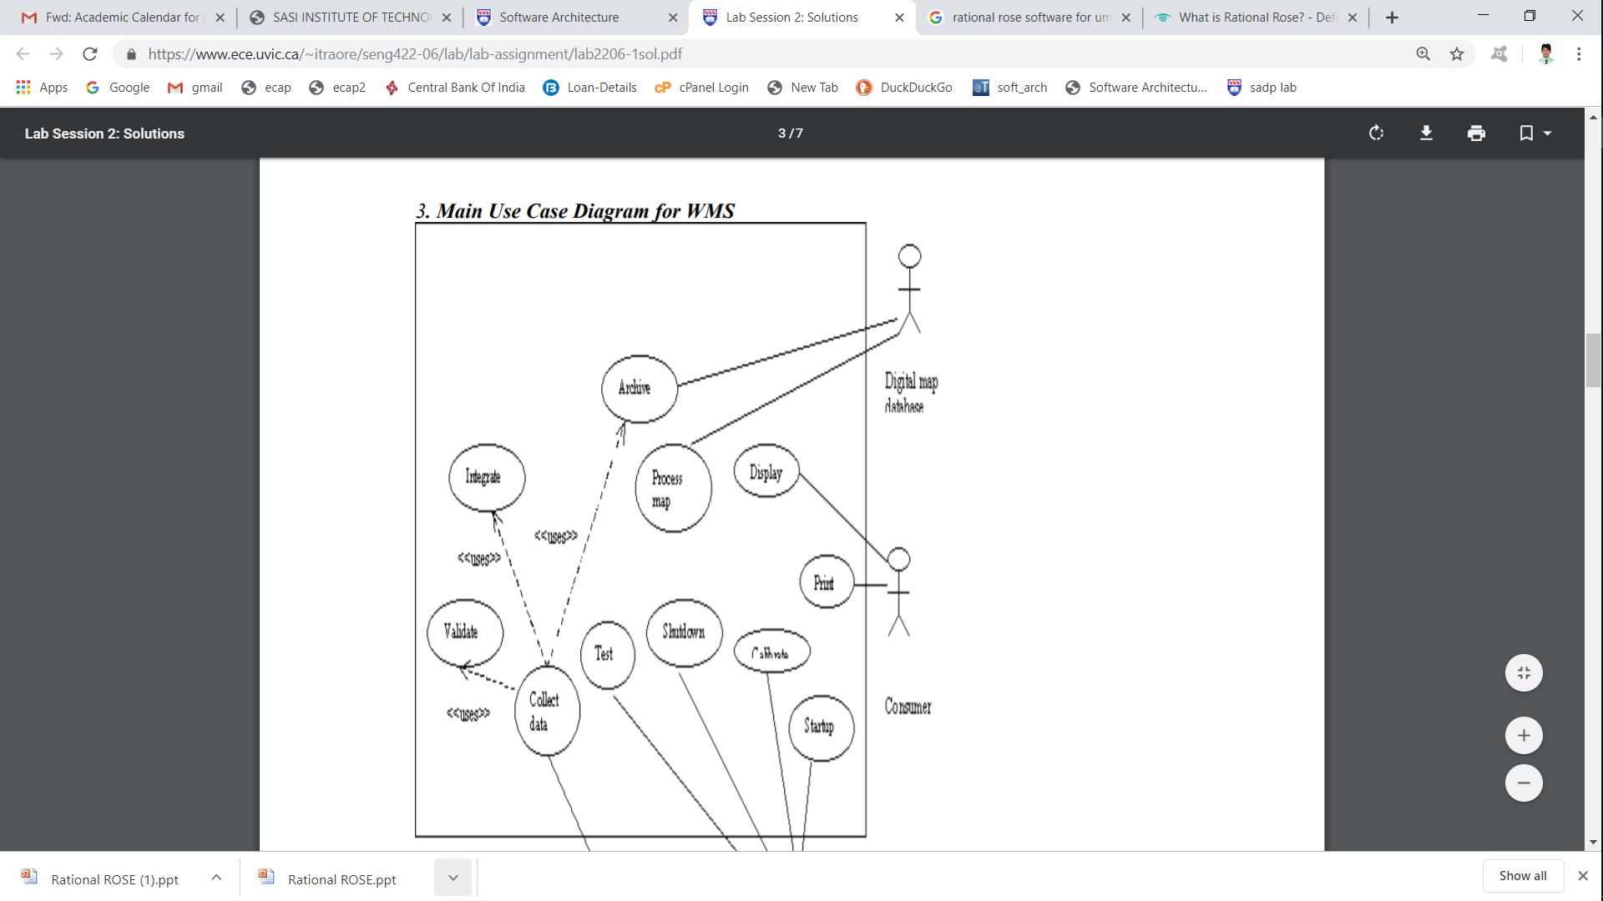

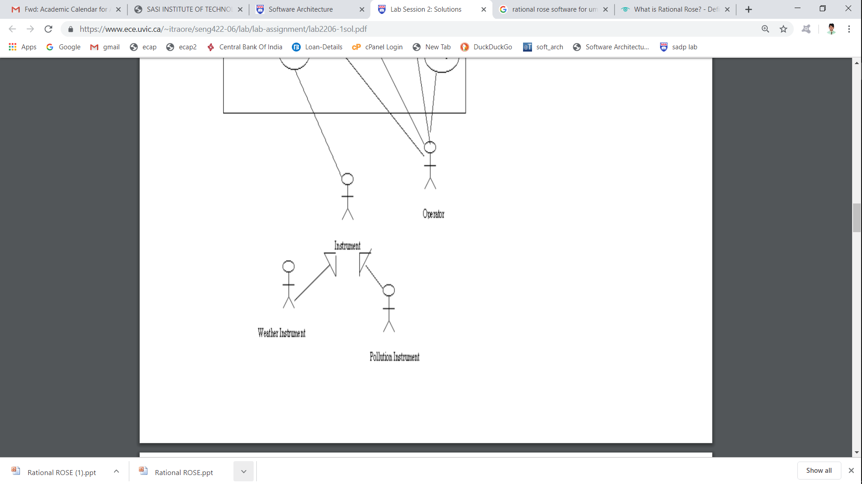

***B. Risk Analysis***

1. ***Cause-effect tree***

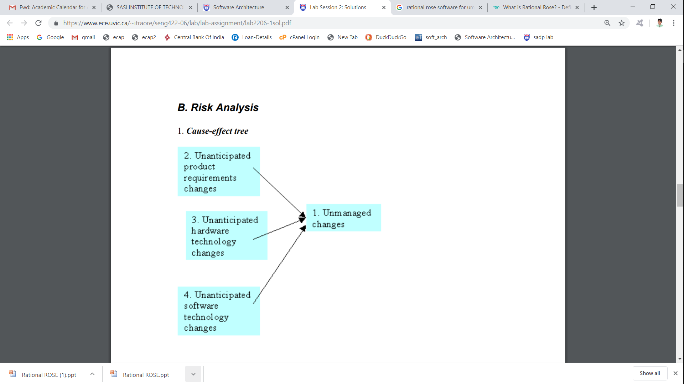

***Risk Registry***

|  |  |  |  |  |  |  |  |
| --- | --- | --- | --- | --- | --- | --- | --- |
| **Risk** | **Description** | **Causes** | **Source of**  **uncertainty** | **Nature** | **Probability** | **Impact** | **Reduction**  **Measures** |
| 1 | Unmanaged changes: failure to cope with the changes occurring in the system development or operation; excessive cost or effort required modifying, updating, evolving, or repairing the system during its operation. | Project fails | Event | Some of the components may remain stable and other may change over time. | L | E | S1: Identify, and Isolates functionalities and components, which are likely to change.  S2: Make it easy to add or remove components (modular design, separation of policy and implementation, separation of interface and implementation etc.) S3: Portable design (use open standards and technologies; use platform independent technologies and standards such as Java and CORBA) |
| 2 | Unanticipated product requirements changes: product requirements such as the frequency or procedures of weather data reporting by weather stations may change in the future. | 1 | Event | Complex design; Design lack of flexibility. | L | E | S1, S2 |
| 3. | Unanticipated hardware technology changes: physical characteristics of the weather data acquisition instruments may change in the future. | 1 | Event | Complexity, lack of portability. | L | E | S1,S3 |
| 4. | Unanticipated software technology changes: upgrade of COTS components, standard changes (e.g. file formats, communication of weather information etc.) | 1 | Event | Complex design; design lack of flexibility | L | E | S1, S2, S3 |

The collect data use case is related to the change management risk in several respects:

Weather data acquisition instruments change, weather information communication Procedure and standard change etc.

***Flow of Events Description***

The flow of events should include:

- When and how the use case starts and ends

- What interaction the use case has with the actors

- What data is needed by the use case

- The normal sequence of events for the use case

- The description of any alternate or exceptional flows

The following description may be given for the *Collect data* use case:

***1.0Flow of Events for the Collect Data Use Case***

***1.1Preconditions***

*The main flow of the Startup use case needs to complete before this use can start.*

***1.2 Main Flow***

*This use case begins when the weather data collection system establishes a modem link with the weather*

*station and requests transmission of the data. The weather station sends an acknowledgment to the*

*collection system (E-1), and then collects and summarizes the data from the weather (S-1) and air (S-2)*

*data instruments. The summarized data is sent to the weather data collection system.*

***1.3 Sub flows***

*S-1: Report weather data*

*Weather data readings are collected and reported from weather data instruments. The data sent are the*

*maximum, minimum and average ground and air temperatures, the maximum, minimum and average air*

*pressures, the maximum, minimum, and average wind speeds.*

*S-2: Report air data*

*The pollution readings are collected and transmitted at the same time as the weather data.*

*The pollution data collected are NO, smoke and benzene rates*

***1.4 Alternative Flows***

*E-1: The collection system hasn’t received any acknowledgment after a certain deadline. The main flow of*

*Test use case is started. The use case is terminated and an error message is displayed.*

**1. C. Logical View:** Design of the Logical View of the Weather Mapping System (WMS).

***A. Use Case Realization***

The realization of a use case is called *collaboration*. A use case is a collection of scenarios, each describing specific aspect of the use case. We consider two scenarios of the *Collect data* use case called *Report Weather Readings* and *Report Air Quality*:

- *Report Weather Readings*: encompasses functionality for reading weather data from remote sources. More specifically weather stations transmit the data collected from weather instruments to the area computer when they receive a request from that machine.

- *Report Air Quality Readings*: the pollution readings are automatically collected when requested by a weather station and transmitted at the same time as the weather data.

1. The flow of events for a use case is captured in text, whereas scenarios are captured in interaction diagrams.

There are two types of interaction diagrams:

Sequence diagrams that show object interactions arranged in time sequence, and

Collaboration diagrams, which show object interactions organized around the objects and their links to each other. Both represent an alternate way of describing a scenario.

* 1. Give using Rational Rose the sequence diagram corresponding to the *Report Weather Readings* and the *Report Air Quality* scenarios. (30%)
  2. Give an alternate representation for the same scenarios using collaboration diagrams. (10%)

2.

a. Identify the boundary, entity and control classes involved in these scenarios. Create these classes using Rational Rose and add if applicable appropriate stereotypes. (10%)

b. Class diagrams may also be attached to use cases and contain a view of the classes participating in the use case. Create using Rose a view of participating classes to the *Collect data* use case. (10%)

c. Identify the relationships among the classes involved in the scenarios, and create them in the corresponding class diagram using Rose. (10%)

3. Create the attributes and operations involved in the classes participating in the *Collect data* use case and document them using Rose.

The documentation for an operation should state briefly the functionality performed by the operation. It should also state any input values needed by the operation along with the return value of the operation. This information may not be known initially, in which case it should be added later when more is known about the class. The documentation for an attribute should state concisely the purpose of the attribute, not the structure of the attribute. (30%)

**Solutions**

A. ***Use Case Realization***

**1.a *- Report Weather Readings Scenario***

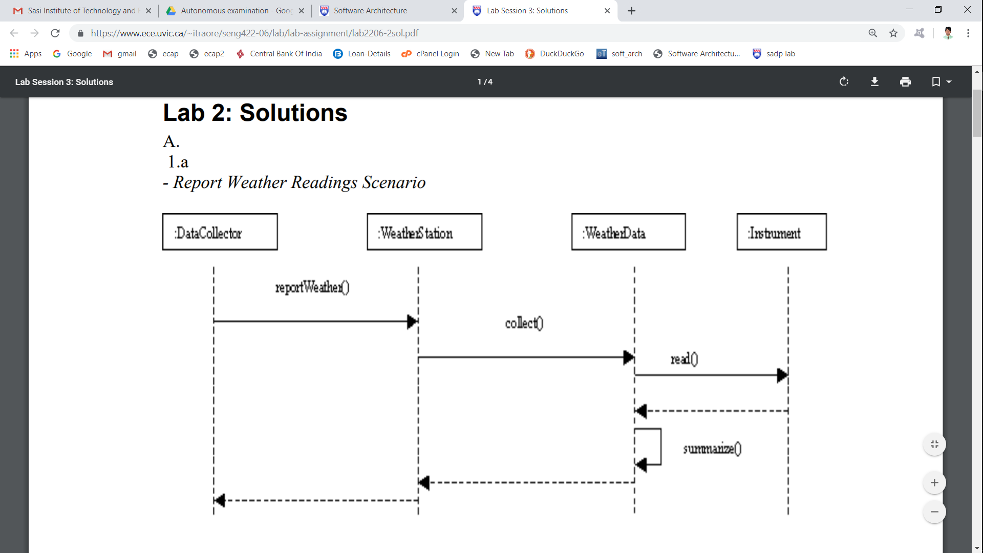

***- Report Air Quality readings Scenario***

Both diagrams are similar: you may describe both scenarios using one diagram, in which case you should describe the concurrency aspects

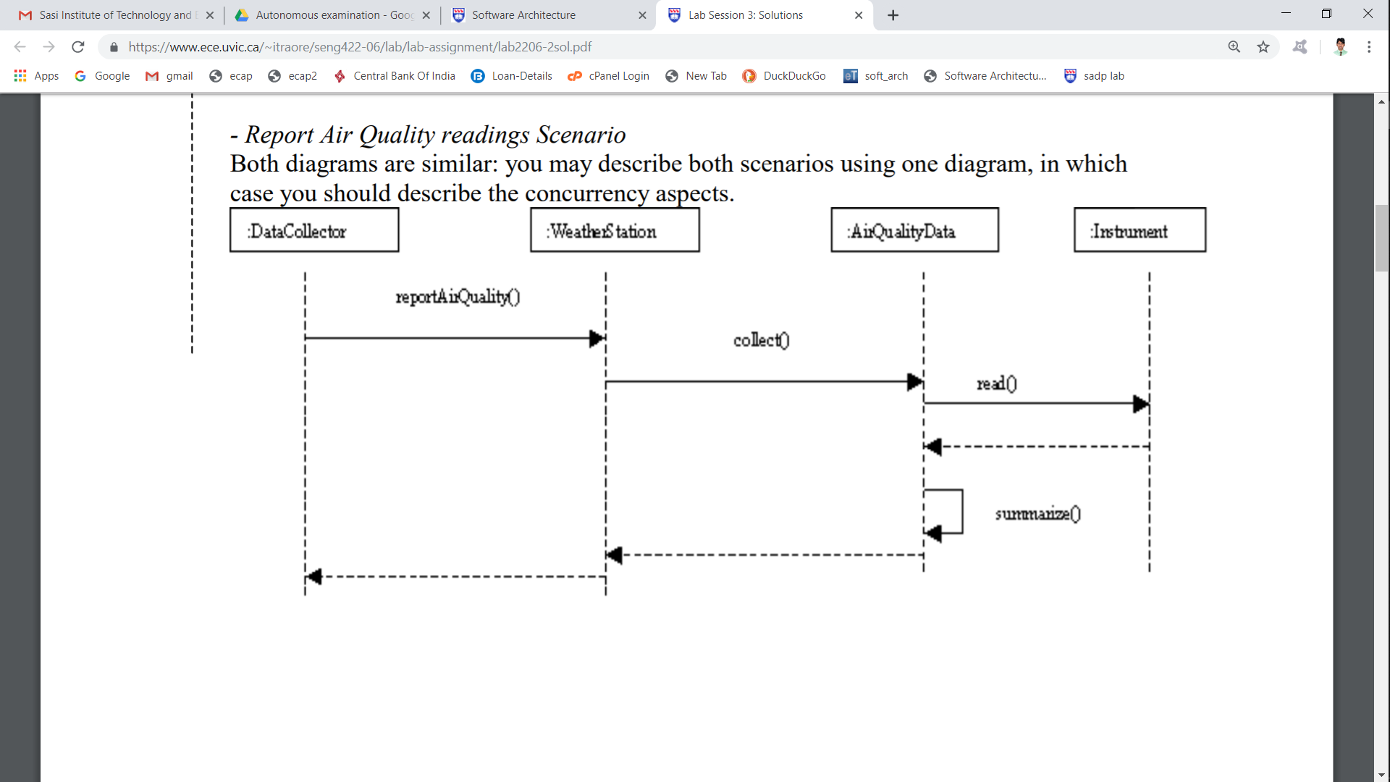

b. Collaboration and sequence diagrams are dual; using Rose, you can generate either diagram from the other automatically. In any case, you must find the same objects, messages, and communication paths.

2.

a. Entity class models information and associated behavior that is generally long lived. This type of class is typically independent of their surroundings; that is they are not sensitive to how the surroundings communicate with the system. Boundary classes handle the communication between the system surroundings and the inside of the system. They can provide the interface to a user or another system. Control classes model sequencing behavior specific to one or more use cases: they represent the dynamics of the use case.

* + **Boundary classes**: this use case interacts only with the data collection instruments. Hence, the boundary classes would be the classes encapsulating the instruments (weather and air data collection instruments: GroundThermometer, Anemometer, Barometer,Nometer, Smokemeter and Benzenmeter).
  + **Entity classes**: this scenario deals with weather and air data collection. We can identify two entity classes*: WeatherData* and *AirQualityData. AirQualityData* class represents the air quality data.
  + **Control classes**: there are two control classes that handle the flow of events for the use case: *WeatherStation* and *DataCollector*.

b. and c. We derive the classes participating to the use case from the interaction diagrams.

We shall find in the class diagram the same relationships (correspond to the message

flows) and the same operations.

***Operations:***

Operations may be identified using interaction diagrams: operations are associated to the

messages exchanged.

Documentation for the collect() operation of the WeatherData class:

*Collect weather information from the weather instruments.*

*Inputs: request from the weather data collection subsystem*

*Outputs: summarised weather data sent to the weather collection subsystem.*

***Attributes:***

Example: attributes and operations for WeatherStation class:



Documentation for the *identifier* attribute of the *WeatherSation* class:

*The unique reference used to distinguish any weather station in the WMS system.* The documentation should state briefly the purpose of the attribute, not the structure of the attribute. For instance a bad definition for the *identifier* attribute would be *“a character string of length 15”.*

**Diagram:**

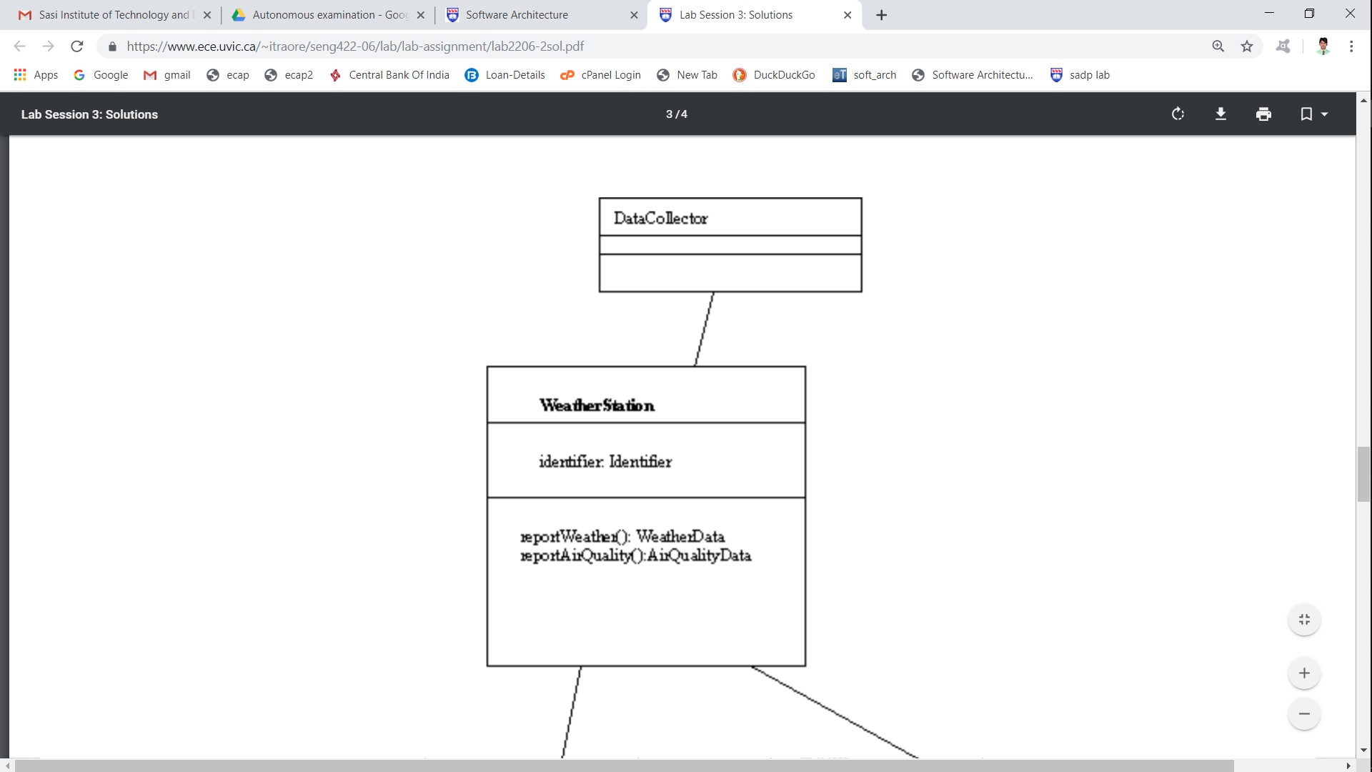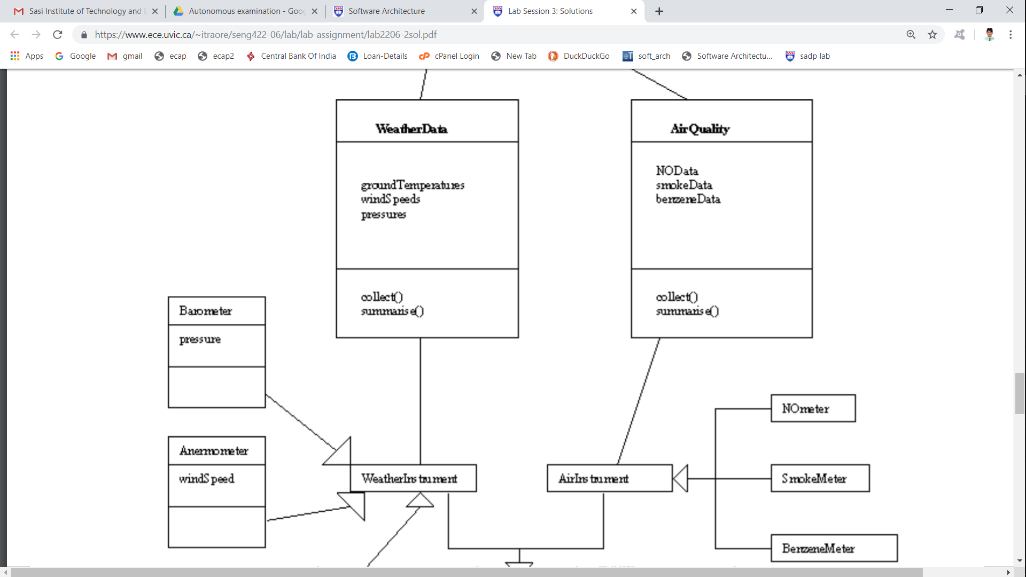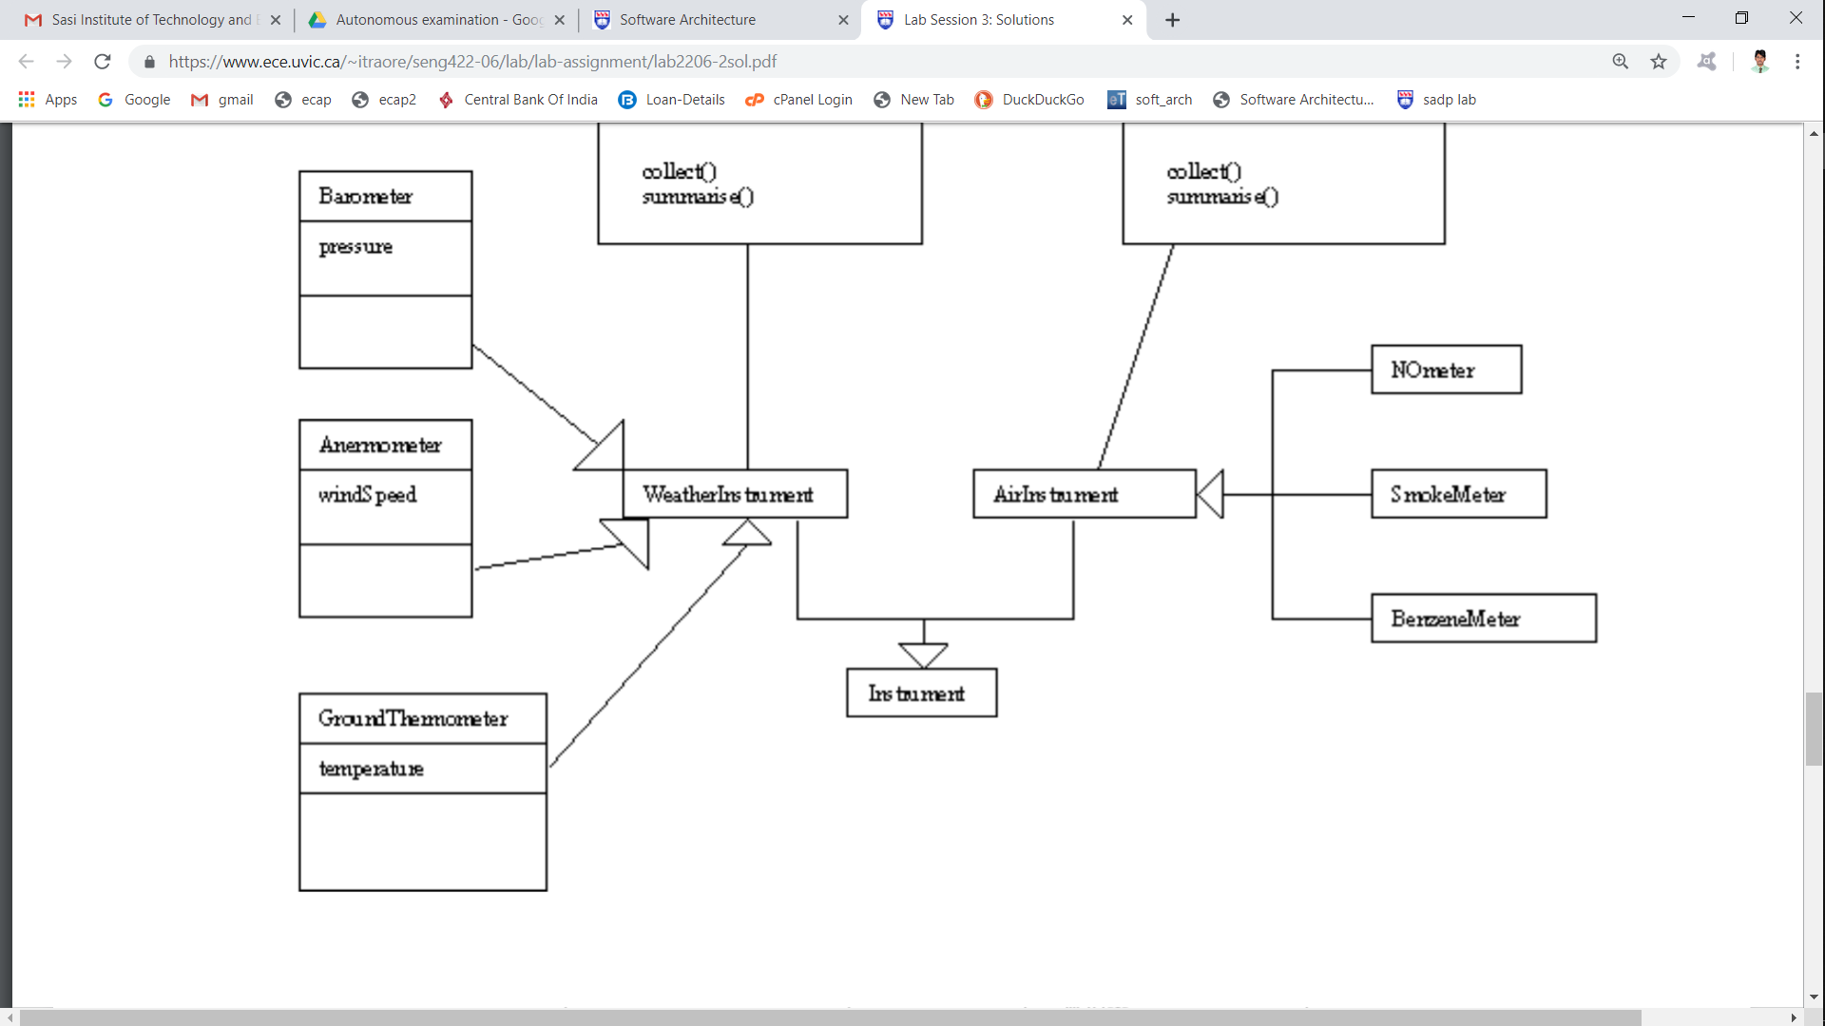

**Viva Questions:**

1. What is Software Architecture?
2. What is whether mapping system?
3. What are the Architectural patterns?
4. Explain the need of whether mapping system?

|  |  |  |  |  |  |  |  |  |  |  |
| --- | --- | --- | --- | --- | --- | --- | --- | --- | --- | --- |
| 0: Not Completed |  | 3: Late Complete/ In complete | | | | | |  | 6: Complete |  |
|  |  |  | | | | | |  |  |  |
|  |  | | |  | | | | | | |
| Viva Voce |  | |  | |  |  |  | | | |
| **Signature of the Instructor** | | | | | | | | | | |

**Experiment No-2 Date: / / 20**

**Integrating Patterns in the Architecture:**

**AIM:** Integration of selected architectural and design patterns in the logical view obtained previously.

**Description:**

Figure 1 depicts a class diagram describing the static structure of the classes participating to the *Report weather data* scenario of the *Collect data* use case. The diagram consists of eight classes. Classes *WeatherStation*, *WeatherData*, *Instrument*, *GroundThermometer, Barometer*, and *Anemometer* describe the data collection functions carried by the weather stations and associated instruments. Classes *DataCollector* and *ArchivedData* describe data collection functions carried by the area computer.

- **WeatherStation:** provides the basic interface of a weather station with its environment.

- **WeatherData:** encapsulates the summarised data from the different instruments in a weather station.

- **Instrument, GroundThermometer, Barometer, and Anemometer:** represent corresponding weather instruments in the system.

- **DataCollector:** sends data collection requests to Weather stations, and stores the received data.

- **ArchivedData:** represents the data collected by the area computer from a weather

station; it encapsulates the collected data, the collection date and time, and the identifier of the source station.

- ***Identifier, Date, Time, and Readings*** are user-defined types: *Identifier is a* userdefined type consisting of a sequence of 4 digits; *Readings* is a record type whose fields correspond to maximum, minimum, and average weather readings (e.g.temperature, pressure etc); *Date (day,month,year)* and *Time (hour,minute,second)*are also defined as record types.

Some of the patterns selected by the architecture team as structuring mechanisms for the software architecture, include the *pipes-and-filters* architectural pattern and the *factory*

design pattern.

1. Based on the risk factors identified during the risk analysis (conducted in Lab1) explain (briefly) why these patterns are appropriate for handling some of the design issues underlying the development of the weather mapping system. (20%)

2. Re-organize the class diagram given in Figure 1 around the *Pipes-and-filter architectural pattern*: specify the filters, the data source and sink, and the model of pipes used for interconnection. Precisely, you must provide (in your report) the following information: (50%)

* 1. *Filters*: indicate for each filter whether it is active or passive; specify corresponding classes (a filter may match one or several classes).
  2. *Data sink* and *source:* indicate whether they are active or passive; specify corresponding classes.
  3. *Pipes*: specify for each pair of filters (including data source and subsequent filter, or data sink and preceding filter) the model of pipes used for interconnection, either as direct call or synchronization pipeline. For synchronization pipelines, specify whether they use a push, a pull, or a mix model.

3. Use the *Factory design pattern* to re-design the class structure of the various classes corresponding to weather instruments, and update the class diagram accordingly. (10%)

4. Reusability, extensibility and maintainability are some the main quality factors that characterize the weather mapping system. Organizing the system into loosely coupled and highly cohesive subsystems (e.g. modules) is one of the strategies used to achieve these quality goals. Decomposition in three subsystems named *Sensors, Station,* and *DataCollection* is considered. Two possible grouping strategies are proposed in Tables 1 and 2. Select the most suitable one, and

motivate your choice by computing a coupling metric such as CBO (Coupling Between Object Classes). Create the subsystems using Rational Rose, and relocate the classes in the Rose Browser. (20%)

|  |  |
| --- | --- |
| Instrument, Ground Thermometer ,Barometer, Anemometer | Sensor |
| Weather Station, Weather Data | Station |
| Data Collector, Archived Data | Data Collection |

*Table 1: Grouping 1*

|  |  |
| --- | --- |
| Classes | Subsystems |
| Instrument, Ground Thermometer ,Barometer, Anemometer, Weather Data | Sensor |
| Weather Station | Station |
| Data Collector, Archived Data | Data Collection |

*Table 2: Grouping 2*

**Output:**



**Implementation, Process, and Deployment Views:**

**Aim**: Design of the implementation, process, and deployment views for the Weather Mapping System.

**Description:**

***A. Process and Deployment Views***

After studying the subsystems defined for the problem, examining existing hardware, and estimating the load on the system during normal operation, the architecture team decided that they will need seven processors for the system: two for the system operators to access the system, one for the database, one for the data processing activities, and three for data sources. The data source processors are located at the weather stations: one processor per station (e.g. we assume that there are three stations).

1. Identify the runtime entities (e.g. process, thread etc.) involved in the *Collect data use case* and provide a corresponding class diagram showing the relationships among them using Rose (use suitable stereotypes). 30%

2. The deployment view of architecture involves mapping software to processing nodes: it shows the configuration of run-time processing elements and the software processes living in them. Create using Rose the deployment diagram for the WMS system. 30%

***B. Implementation View for WMS***

The architecture team decided that the classes encapsulating the functionality of weather data acquisition instruments would be designed as DLL (Dynamic Loadable Library). This allocation was chosen in order to anticipate future change of the weather instruments. By making them libraries, only the libraries would have to be replaced in case of change.

1. Create using Rose a UML component diagram depicting the executable release for the classes participating in the *Collect data* use case. A release is a relatively complete and consistent set of artifacts delivered to an internal or external user. A release focuses on the parts necessary to deliver a running system. 40%

**Output:**

**A. Process and Deployment Views**

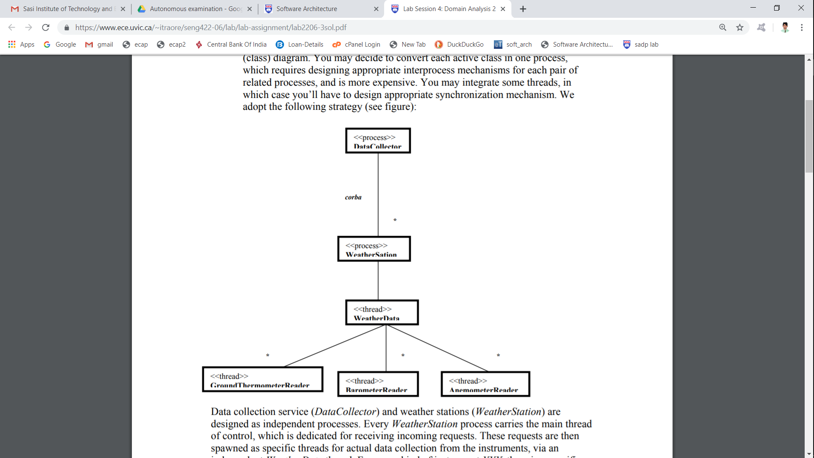

Data collection service (DataCollector) and weather stations (WeatherStation) are designed as independent processes. Every WeatherStation process carries the main thread of control, which is dedicated for receiving incoming requests. These requests are then spawned as specific threads for actual data collection from the instruments, via an independent WeatherData thread. For every kind of instrument XXX, there is a specific XXXReader thread that is spawned. The XXXReader thread will collect readings from all the related instruments and then return the minimum, maximum, and average values.

**2. Deployment diagram:**

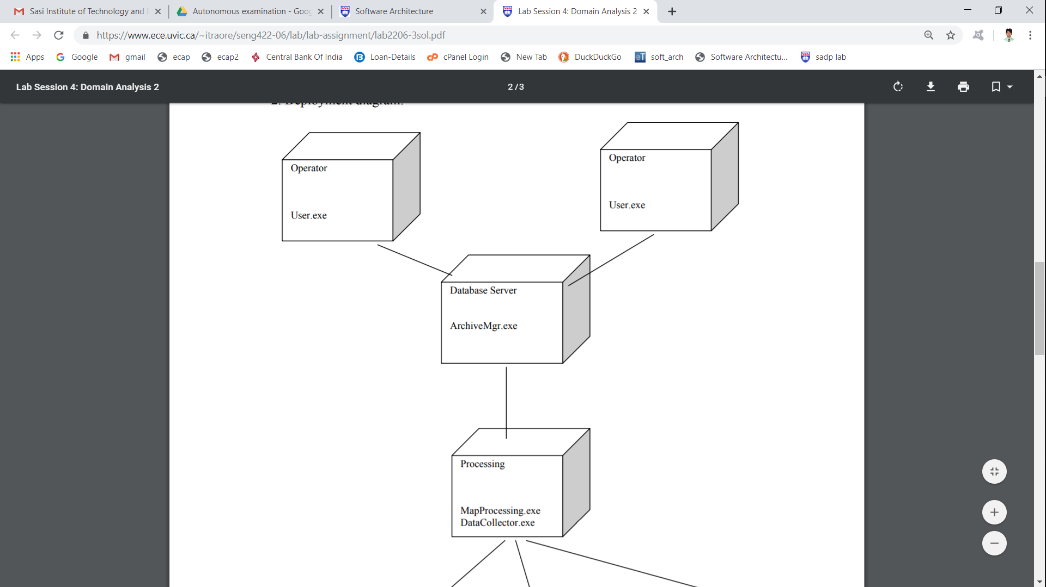

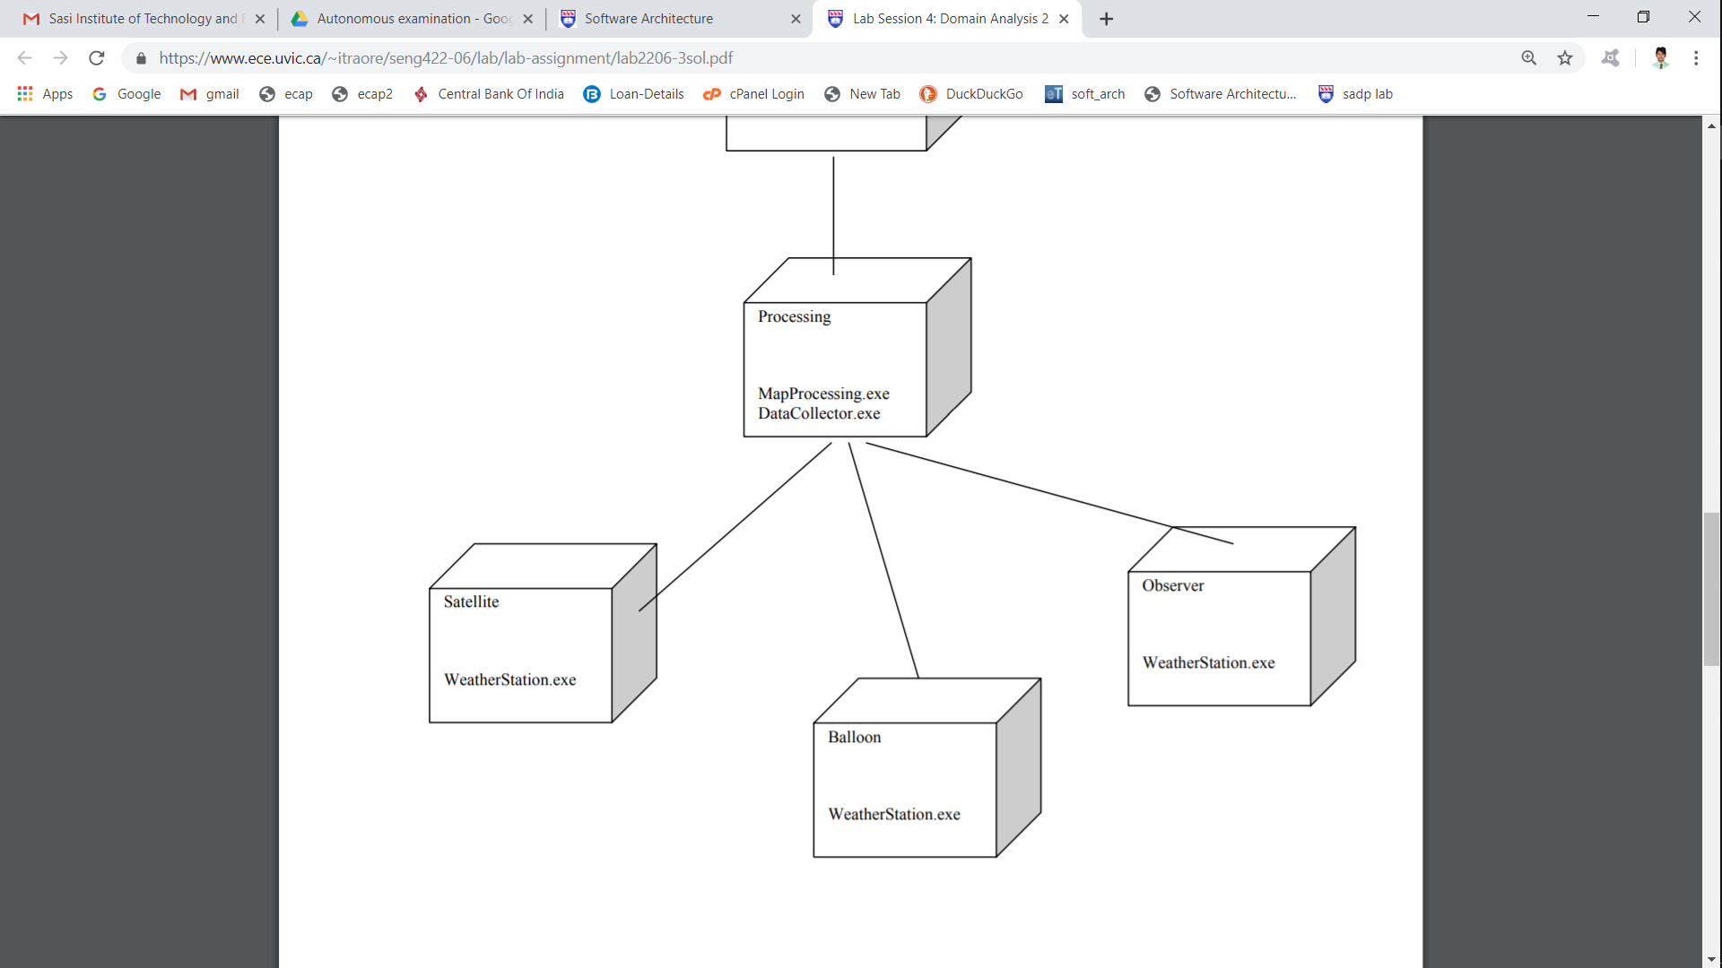

## B. Implementation View

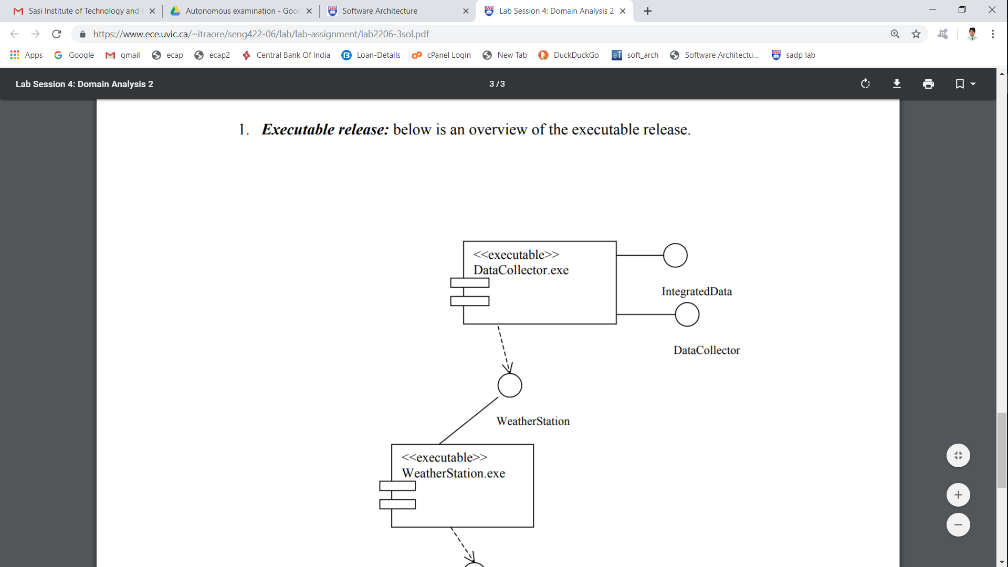

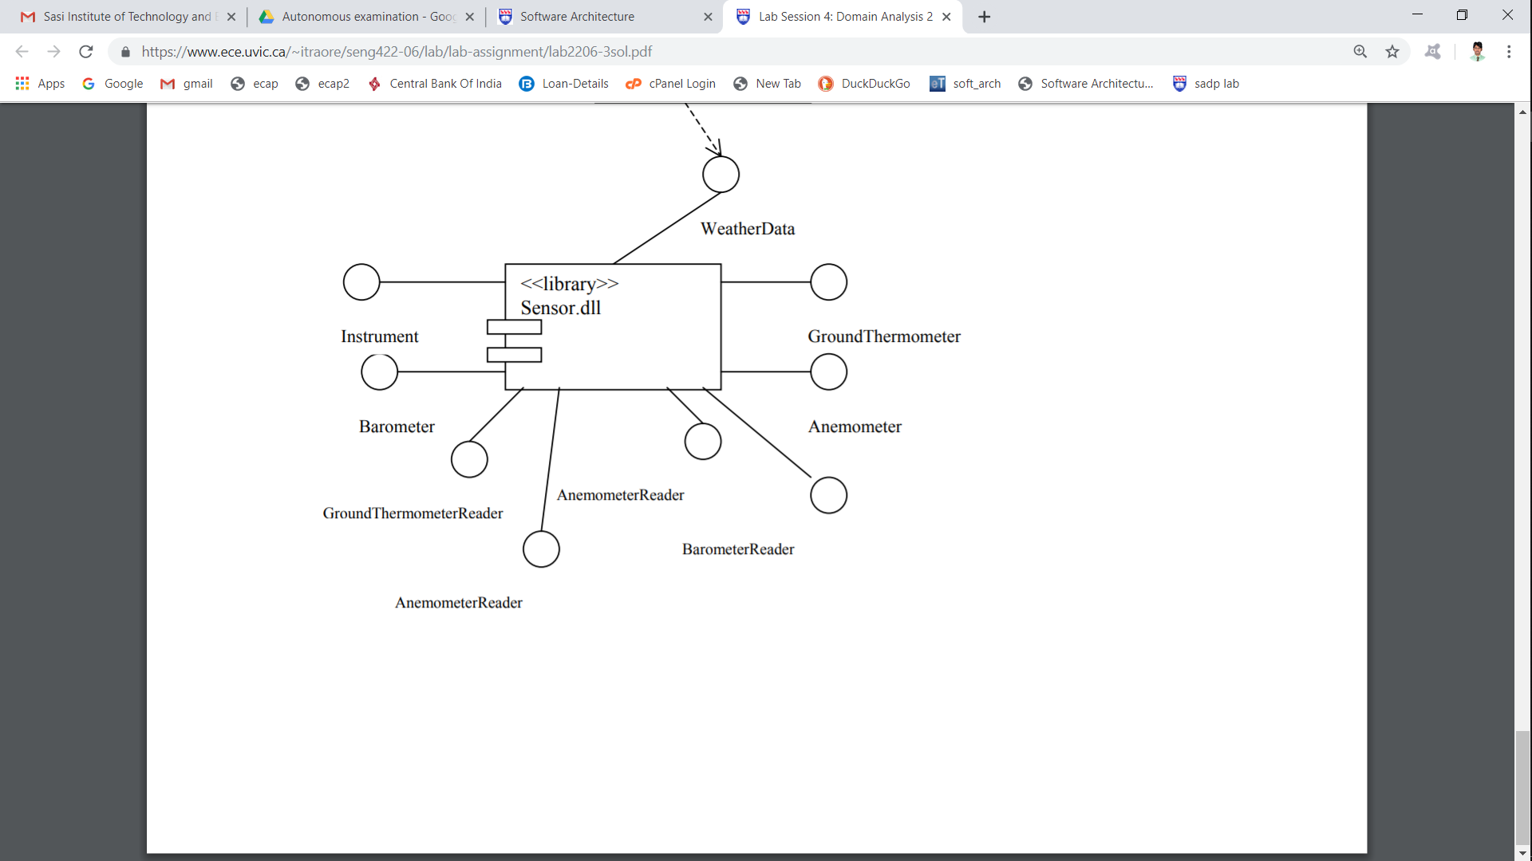

**Viva Questions:**

1. **What are Boundary classes?**
2. **What is Entity Class?**
3. **What is control class?**
4. **What is** Quality Attributes,**?**
5. **What are** Achieving qualities?

|  |  |  |  |  |  |  |  |  |  |  |
| --- | --- | --- | --- | --- | --- | --- | --- | --- | --- | --- |
| 0: Not Completed |  | 3: Late Complete/ In complete | | | | | |  | 6: Complete |  |
|  |  | | |  | | | | | | |
| Viva Voce |  | |  | |  |  |  | | | |
| **Signature of the Instructor** | | | | | | | | | | |

**Experiment-3 Date: / / 20**

**Component and Inter process Communication Design:**

**Aim:** Generation from the previous architecture design of CORBA Interfaces and Components Definitions

**Description:**

The architecture team has decided to use the CORBA standard for the design of the inter process communication mechanisms and the software components involved in WMS. Figure 1 depicts the new class diagram describing the static structure of the classes participating to the *Report weather data* scenario of the *Collect data* use case. We assume that each weather station is connected to 3 instances of each kind of instruments (e.g. 3 barometers, 3 ground thermometers etc.). We assume also for the sake of simplicity that there are only two weather stations.

1. Refine the class diagram in order to provide a new diagram consisting only of corresponding CORBA interfaces and types definitions. More specifically your diagram must include:

* CORBA Interfaces
* Data types definitions for the parameters and arguments involved in the operations using Rose-CORBA stereotyped classes.
* Definition and documentation when needed (using Rose) of the relationships among the different elements involved.

2. Based on the modularization strategy adopted in previous Labs, generate using Rose the IDL code corresponding to the refined class diagram obtained previously. The generated IDL code should consist of at least three modules corresponding to the different subsystems (for example *Sensor, Station*, and *DataCollection)*.

**Output:**



**Implementation of WMS**

**Aim:** Implementation of the Weather Mapping System (Java & C++), with a particular emphasis on the Interprocess communication mechanism and the software components identified.

The project consists essentially of implementing in Java or C++ some of the CORBA objects identified for the Weather Mapping System, deploying them, and then testing them using a Java or C++ Client. The implementation will be based on the software architecture designed during the lab sessions.

1. Based on the IDL codes generated in Lab 5, implement in C++ and/or Java. You may implement weather instruments as simple random number generators. Use the following range for the weather readings:

- Temperature: [-80oC, +70oC] (oC: Degree Celsius)

- Pressure: [800,1100mbar] (mbar: millibars)

- Wind Speed: [0, 250mph] (e.g. mph: miles per hour).

2. Deploy copies of your packages on two different machines. Each server runs on a separate machine, and represents a remote weather station.

3. Implement the data collection client; the data collection client is in principle deployed on a central and separate computer. The data collection client is a CORBA client that will request and store (in a file or database) weather data from the two remote weather stations. The data collection client may access a remote station by first obtaining a reference to a Station instance from a corresponding server. For testing purpose, the data collection client must provide a user interface through which viewers can access collected weather data. For example, the user can select maximum, minimum, or average of selected weather parameters (e.g. temperature, pressure etc.) for a given location (e.g., weather station). Deploy the data collection client on a third machine.

4. Deploy and test your application. In order to simulate the different weather stations, you’ll deploy copies of your components on two different machines (each running on different machine). You’ll also deploy your client on a separate computer (e.g., a third one)

**Viva Questions:**

1. **Explain** reference models,**?**
2. **Need of** reference models,**?**
3. **What is an architecture view?**
4. **What are the** Architectural styles**?**
5. **What is the need of** Reconstructing Software Architecture?

|  |  |  |  |  |  |  |  |  |  |  |
| --- | --- | --- | --- | --- | --- | --- | --- | --- | --- | --- |
| 0: Not Completed |  | 3: Late Complete/ In complete | | | | | |  | 6: Complete |  |
|  |  | | |  | | | | | | |
| Viva Voce |  | |  | |  |  |  | | | |
| **Signature of the Instructor** | | | | | | | | | | |

**DESIGN PATTERNS**

***Design Patterns*:** Each pattern describes a problem which occurs over and over again in our environment, and then describes the core of the problem

***Design Patterns***are the best solutions for the re-occurring problems in the application programming environment.

***Design Patterns*** are very much about choices and alternatives. Frequently more than one design pattern could be used to solve a given problem. E.g. Template Method vs Strategy, Strategy vs State.

**Design Pattern Elements**

1. **Pattern Name**

Handle used to describe the design problem

Increases vocabulary

Eases design discussions

Evaluation without implementation details

1. **Problem**

Describes when to apply a pattern

May include conditions for the pattern to be applicable

Symptoms of an inflexible design or limitation

1. **Solution**

Describes elements for the design

Includes relationships, responsibilities, and collaborations

Does not describe concrete designs or implementations

A pattern is more of a template

1. **Consequences**

Results and Trade Offs

Critical for design pattern evaluation

Often space and time trade offs

Language strengths and limitations

(Broken into benefits and drawbacks for this discussion)

**Design patterns can be subjective.**

One person’s pattern may be another person’s primitive building block.

The focus of the selected design patterns are:

Object and class communication

Customized to solve a general design problem

Solution is context specific

**Describing design patterns**

* Graphical notations, while important and useful, aren’t sufficient.  
  They capture the end product of the design process as relationships between classes and objects.  
  By using a consistent format we describe the design pattern.

Each pattern is divided into sections according to the following template.

**Pattern Name and Classification:**

* it conveys the essence of the pattern succinctly good name is vital, because it will become part of design vocabulary.

Intent: What does the design pattern do?

* What is its rational and intend?
* What particular design issue or problem does it address?

Also Known As: Other well-known names for the pattern, if any.

Motivation:

* A scenario that illustrates a design problem and how the class and object structures in the pattern solve the problem.
* The scenario will help understand the more abstract description of the pattern that follows.

**Applicability:**

* Applicability: What are the situations in which the design patterns can be applied?
* What is example of the poor designs that the pattern can address?
* How can recognize situations?
* Structure: Graphical representation of the classes in the pattern using a notation based on the object Modeling Technique (OMT).
* Participants: The classes and/or objects participating in the design pattern and their responsibilities.

**Structure:**

* Graphical representation of the classes in the pattern using a notation based on the object Modeling Technique (OMT).

**Participants:**

The classes and/or objects participating in the design pattern and their responsibilities.

**Collaborations:**

* How the participants collaborate to carry out their responsibilities.

**Consequences:**

* How does the pattern support its objectives?
* What are the trade-offs and result of using the pattern ?
* What aspect of the system structure does it let vary independently?

**Implementation:**

* What pitfalls, hints, or techniques should be aware of when implementing the pattern ?
* Are there language-specific issues?

**Sample Code:**

* Code fragments that illustrate how might implement the pattern in c++ or Smalltalk.

**Known Uses:**

Examples of the pattern found in real systems.

**Related Patterns:**

What design patterns are closely related to this one? What are the imp differences?

With Which other patterns should this one be used?

**Experiment No-4 Date: / / 20**

**Aim:** Use case Diagram for Librarian Scenario

**Problem Statement:**

A library case study is used to identify user interface modeling problems .The Library System in the case study could be considered too simple to catch real problems faced during the modeling of user interfaces. Indeed, the Library System is simple compared with real systems. However, it has proved sufficiently complex to allow a range of problems to be identified in the area of user interface modeling.

Actors in Library system are Librarian, Library database, users-normal user, VIP user. The actor Library System User is a generalization of Librarian and Normal user and VIP user. Librarians use the Library System to manage the book catalogue and the loan records. Librarians only need to inform to the Library System when books are checked into and checked out of the system to be able to manage loan records. Thus, the use cases BorrowBook and ReturnBook, associated with Librarian, are created.

LibrarySystemUsers can connect to the system, list the books borrowed by a library user and search for books by author, title, year or a combination of these. Thus,the use cases associated with LibrarySystemUsers are ConnectToSystem, ListBooksBorrowed ByUser and SearchBook. ConnectToSystem is considered as a use case since a LibrarySystemUser can login to the system just to check his/her password. Borrowers can browse the library database without specifying any condition.

The Library System must guarantee that only registered users can login to the system. Further, the system must guarantee that borrowers can only perform services associated with borrowers, and that librarians can only perform services associated with librarians. Books can be selected while users are searching or browsing the book catalogue. Once a book is selected, users can check its availability.

**Requirements:**

Use Case, Actor, and Relationships.

**Procedure:**

A use case involves the interaction of actors and the system or other subject. An actor represents a coherent set of roles that users of use cases play when interacting with these use cases. Actors can be human or they can be automated systems. For example, in modeling a Library Management System, processing a book involves, among other things, the interaction between a Librarian and a Borrower.

We can apply use cases to your whole system. We can also apply use cases to part of your system, including subsystems and even individual classes and interfaces. In each case, these use cases not only represent the desired behavior of these elements, but they can also be used as the basis of test cases for these elements as they evolve during development. Use cases applied to subsystems are excellent sources of regression tests; use cases applied to the whole system are excellent sources of integration and system tests. The UML provides a graphical representation of a use case and an actor. This notation permits us to visualize a use case apart from its realization and in context with other use cases.

A use-case diagram is typically used to communicate the high-level functions of the system and the system's scope. To show a use case on a use-case diagram, we draw an oval in the middle of the diagram and put the name of the use case in the center of, or below, the oval. To draw an actor (indicating a system user) on a use-case diagram, we draw a stick person to the left or right of our diagram. Use simple lines to depict relationships between actors and use cases.

The diagram has Usecase Diagram of various actions and Actors Each actor has specified number of operations and these operations are related to other actors operations

**From the given problem statement the following use-cases and Actors were being found:**

|  |  |
| --- | --- |
| Actors | Use Cases |
| Librarian  User  New User  Library Database  VIP user  Staff  Student | Login  View All Books  Update Book  Add Book  Delete Book  Manage Book  Borrow Book  Return Book  Reserve Book  Renewal Book  Search Book  Feed Back  Login  Request for VIP user  Maintain Database  User Registration  Request for New Book  Borrow CD  Return CD  Home Delivery |

**Library Management system: Use Case Diagram**

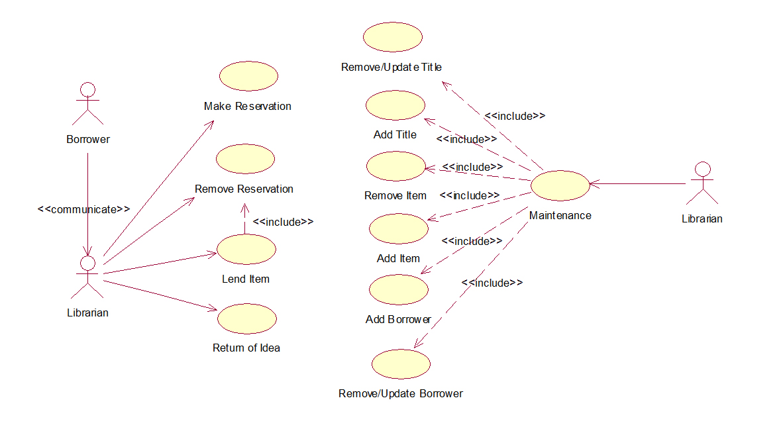

**Aim :** Using UML design Abstract factory design pattern

Description:

**Abstract Factory:** Provide an interface for creating families of related or dependent objects without specifying their concrete classes.

**Diagram:**



**Viva Questions:**

1. Explain Design Patterns?
2. Need of Design Patterns?
3. Difference between UML and Design Patterns?
4. What is abstract factory?
5. What is factory method?

|  |  |  |  |  |  |  |  |  |  |  |
| --- | --- | --- | --- | --- | --- | --- | --- | --- | --- | --- |
| 0: Not Completed |  | 3: Late Complete/ In complete | | | | | |  | 6: Complete |  |
|  |  | | |  | | | | | | |
| Viva Voce |  | |  | |  |  |  | | | |
| **Signature of the Instructor** | | | | | | | | | | |

**Experiment No-5 Date: / / 20**

**AIM:** Using UML design Adapter-class Design pattern

**Description:**

Class patterns deal with relationships between classes and their subclasses. These relationships are established through inheritance, so they are static—fixed at compile-time. Object patterns deal with object relationships, which can be changed at run-time and are more dynamic. Almost all patterns use inheritance to some extent. So the only patterns labeled "class patterns" are those that focus on class relationships. Note that most patterns are in the Object scope.

Creational class patterns defer some part of object creation to subclasses, while Creational object patterns defer it to another object. The Structural class patterns use inheritance to compose classes, while the Structural object patterns describe ways to assemble objects. The Behavioural class patterns use inheritance to describe algorithms and flow of control, whereas the behavioural object patterns describe how a group of objects cooperate to perform a task that no single object can carry out alone.

There are other ways to organize the patterns. Some patterns are often used together. For example, Composite is often used with Iterator or Visitor. Some patterns are alternatives: Prototype is often an alternative to Abstract Factory. Some patterns result in similar designs even though the patterns have different intents. For example, the structure diagrams of Composite and Decorator are similar.

Figure 1.1 depicts these relationships graphically. Clearly there are many ways to organize design patterns. Having multiple ways of thinking about patterns will deepen your insight into what they do, how they compare, and when to apply them.

***Organizing of catalog***

|  |  |  |  |  |
| --- | --- | --- | --- | --- |
|  | | Purpose | | |
| Creational | Structural | Behavioral |
| Scope | Class | Factory Method | Adapter (class) | Interpreter Template Method |
| Object | Abstract Factory  Builder  Prototype  Singleton | Adapter (object)  Bridge  Composite  Decorator  Facade  Flyweight  Proxy | Chain of Responsibility  Command  Iterator  Mediator  Memento  Observer  State  Strategy Visitor |

**Diagram:**

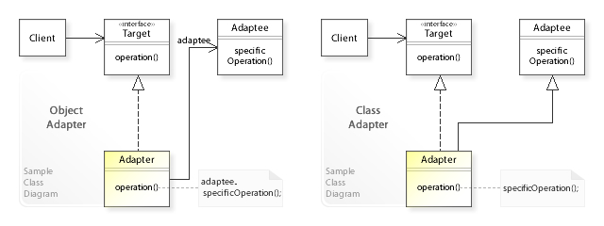

Class diagram for the adapter design pattern

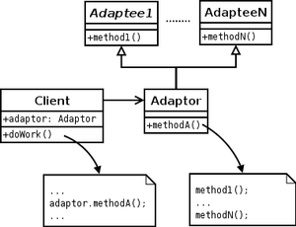

The class adapter pattern

**AIM:** Using UML design Adapter-object Design pattern

**Diagram:**

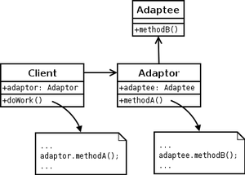

The object adapter pattern 1

**Viva Questions:**

1. What is adapter class?
2. Explain about adapter object?
3. What is Factory method?
4. What is Prototype?
5. Define Singleton?

|  |  |  |  |  |  |  |  |  |  |  |
| --- | --- | --- | --- | --- | --- | --- | --- | --- | --- | --- |
| 0: Not Completed |  | 3: Late Complete/ In complete | | | | | |  | 6: Complete |  |
|  |  | | |  | | | | | | |
| Viva Voce |  | |  | |  |  |  | | | |
| **Signature of the Instructor** | | | | | | | | | | |

**Experiment No-6 Date: / / 20**

**AIM**: Using UML design Strategy Design pattern

**Description:**

**Strategy**: Define a family of algorithms, encapsulate each one, and make them interchangeable. Strategy lets the algorithm vary independently from clients that use it.

**Diagram:**

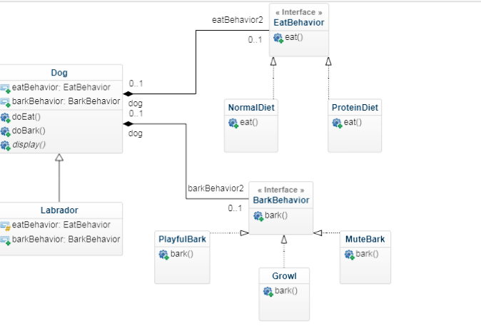

**AIM:** Using UML design Builder Design pattern

**Description:**

**Builder:** Separates the construction of the complex object from its representation so that the same constriction process can create different representations.

**Diagram:**

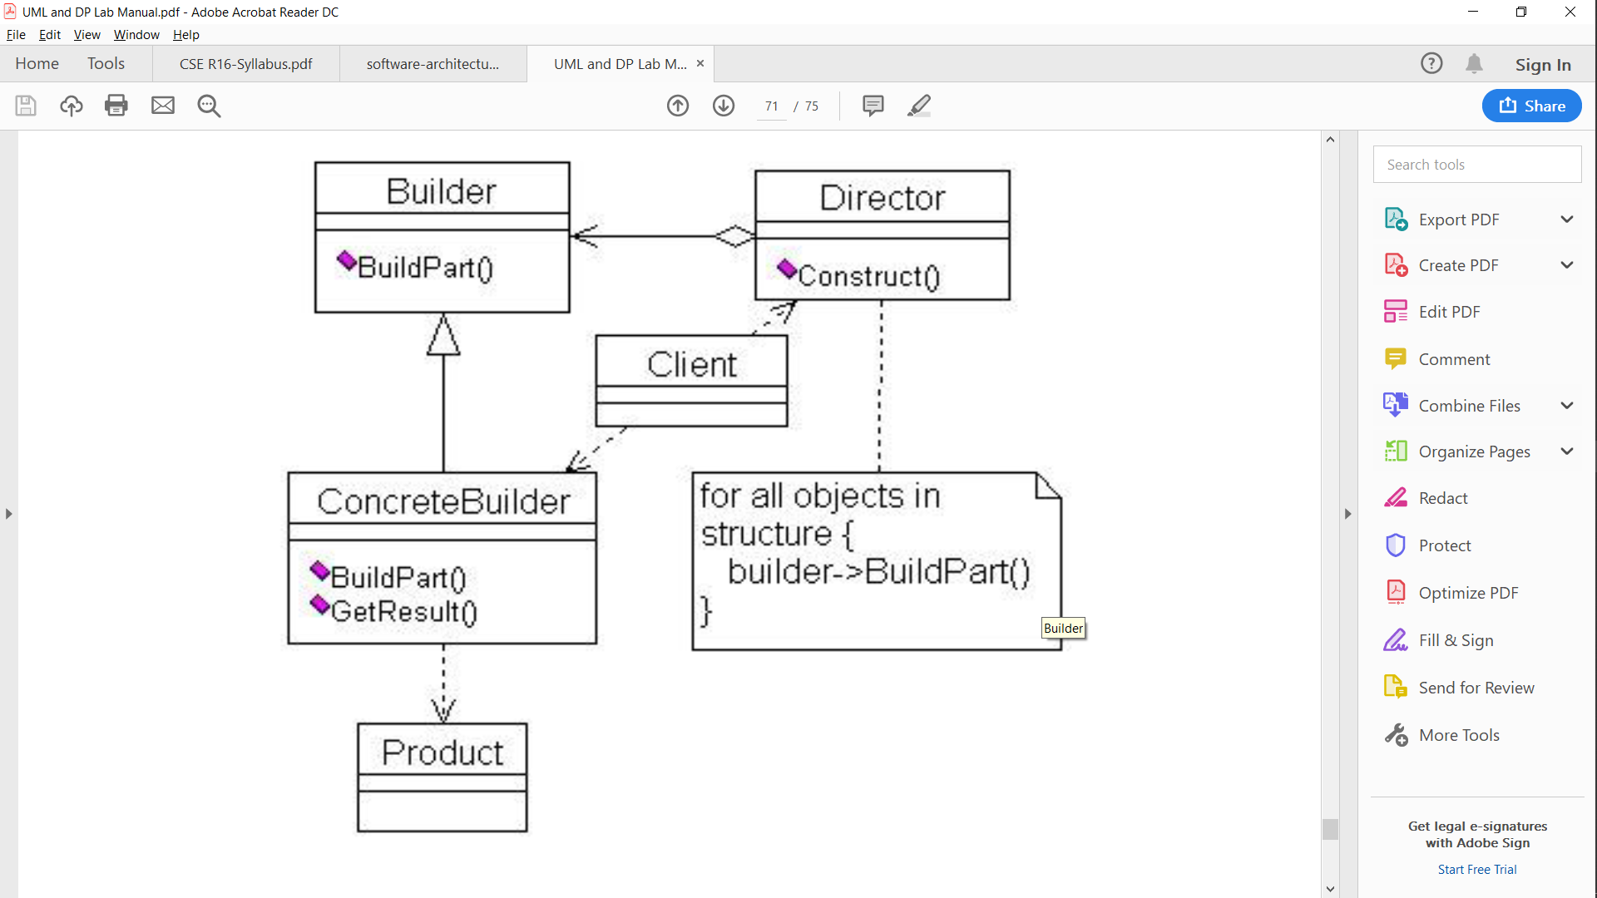

**Viva Questions:**

1. What is Builder Design Pattern?
2. Explain about Strategy Design pattern?
3. What is Organizing catalogs,?
4. What is need of builder design pattern?
5. What is the necessity of Singleton?

|  |  |  |  |  |  |  |  |  |  |  |
| --- | --- | --- | --- | --- | --- | --- | --- | --- | --- | --- |
| 0: Not Completed |  | 3: Late Complete/ In complete | | | | | |  | 6: Complete |  |
|  |  | | |  | | | | | | |
| Viva Voce |  | |  | |  |  |  | | | |
| **Signature of the Instructor** | | | | | | | | | | |

**Experiment No-7 Date: / / 20**

**AIM:** Using UML design Bridge Design pattern

**Description:**

**Bridge:** Decouple an abstraction from its implementation so that two can vary independently.

**Diagram**

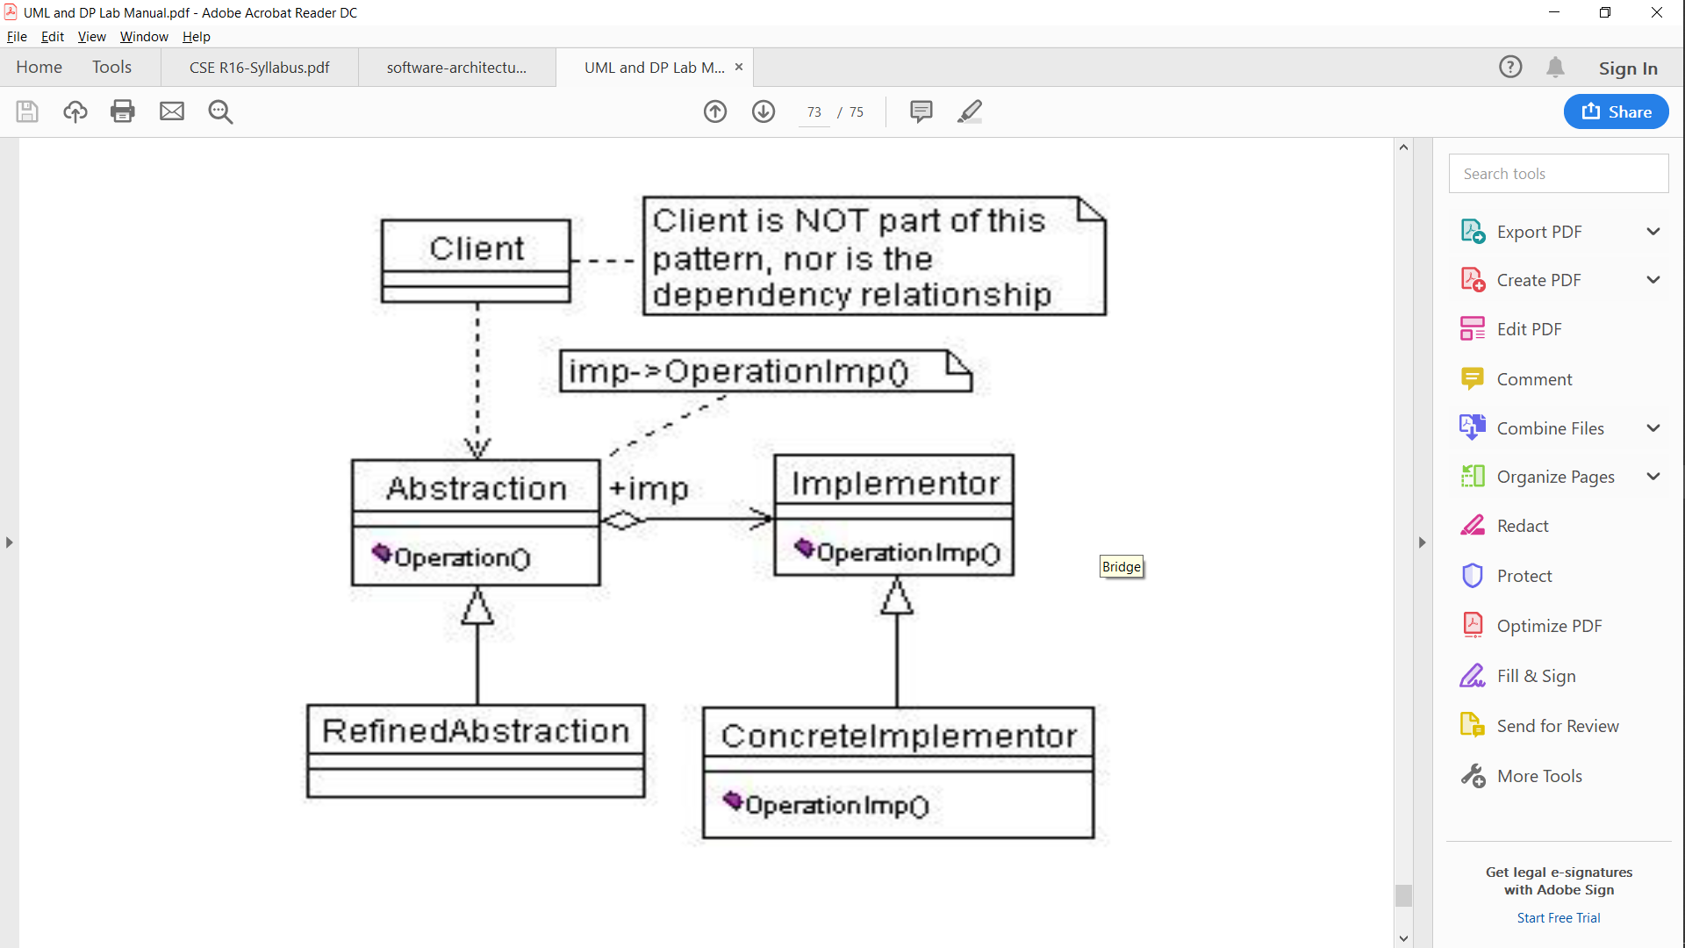

**AIM:** Using UML design Decorator Design pattern

**Description:**

**Decorator:** Attach additional responsibilities to an object dynamically. Decorators provide a flexible alternative to sub classing for extending functionality.

.

**Diagram:**

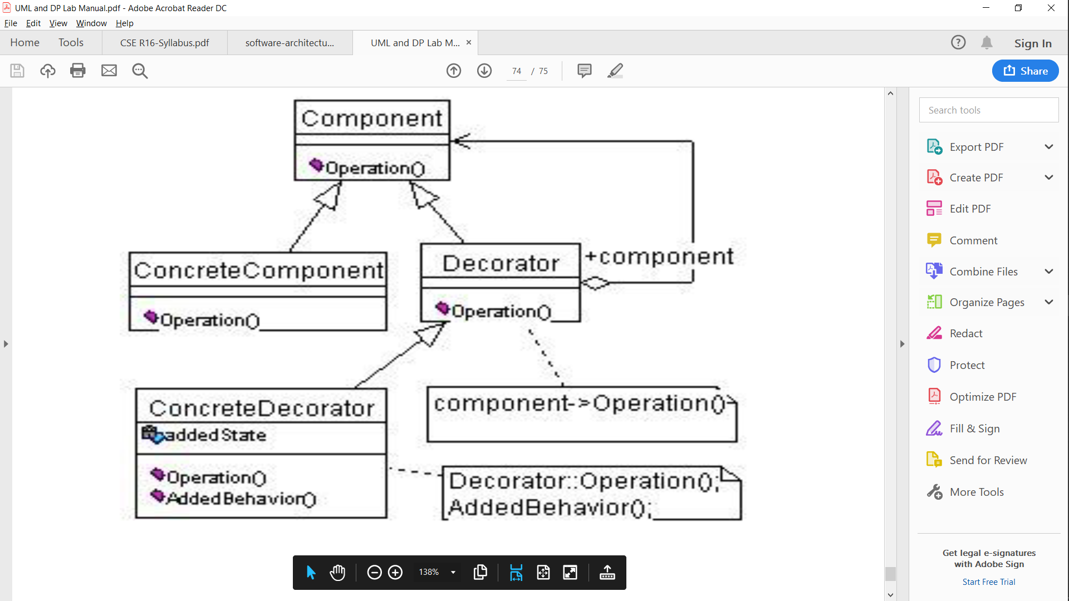

**Viva Questions**

1. Explain about Decorator Design pattern?

2. Explain Bridge Design pattern?

3. What is Structural Patterns?

4. What are the Structural Patterns?

5. What is Adapter Design Pattern?

|  |  |  |  |  |  |  |  |  |  |  |
| --- | --- | --- | --- | --- | --- | --- | --- | --- | --- | --- |
| 0: Not Completed |  | 3: Late Complete/ In complete | | | | | |  | 6: Complete |  |
|  |  | | |  | | | | | | |
| Viva Voce |  | |  | |  |  |  | | | |
| **Signature of the Instructor** | | | | | | | | | | |
|  | | | | | | | | | | |
|  | | | | | | | | | | |

**Experiment 8: Date: / / 20**

**AIM:** User gives a print command from a word document. Design to represent this chain of responsibility Design pattern

**Class diagram for Document Editor:**

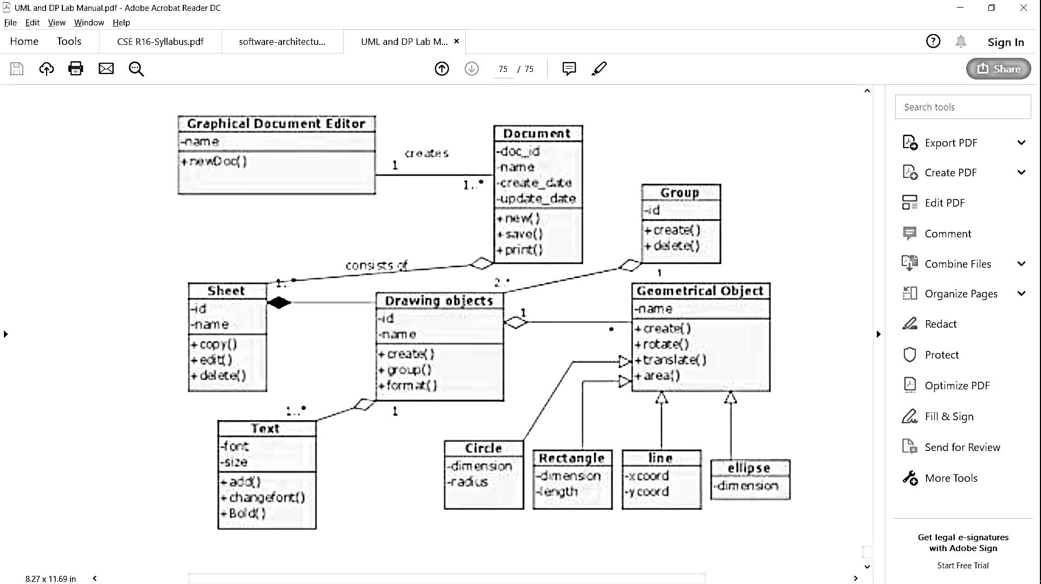

**AIM:** Design a Flyweight Design pattern

**Diagram:**

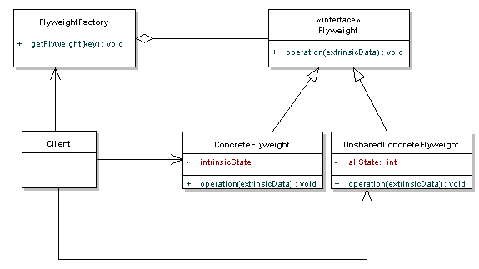

**Viva Questions**

1. Explain about Flyweight?

2. Explain Composite Design pattern?

3. What is Behavioral Patterns?

1. What are the Behavioral Patterns?
2. What is the role of Decorator?

|  |  |  |  |  |  |  |  |  |  |  |
| --- | --- | --- | --- | --- | --- | --- | --- | --- | --- | --- |
| 0: Not Completed |  | 3: Late Complete/ In complete | | | | | |  | 6: Complete |  |
|  |  | | |  | | | | | | |
| Viva Voce |  | |  | |  |  |  | | | |
| **Signature of the Instructor** | | | | | | | | | | |

**Experiment 9: Date: ____/____/20__**

**AIM:** Using UML design Facade Design pattern

**Description:**

**Façade:** Provide a unified interface to a set of interfaces in a subsystem's Facade defines a higher-level interface that makes the subsystem easier to use.

**Diagram:**

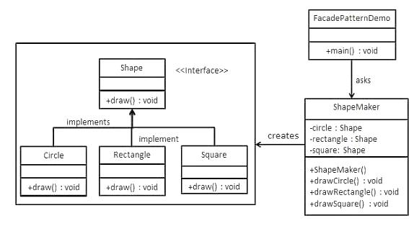

**AIM:** Using UML design Iterator Design pattern

**Description:**

**Iterator:** Provide a way to access the element of an aggregate object sequentially without exposing its underlying representation.

**Diagram:**

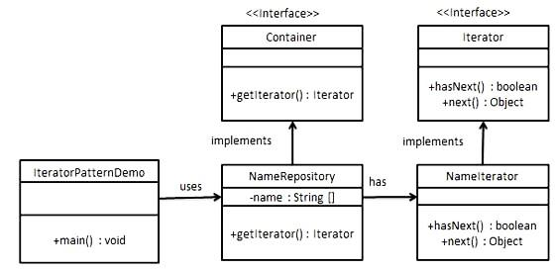

**Viva Questions**

1. Explain about Iterator Design pattern?

2. Explain Facade Design pattern?

3. What is memento?

4. What is Observer?

5. What is the Command in design patterns?

|  |  |  |  |  |  |  |  |  |  |  |
| --- | --- | --- | --- | --- | --- | --- | --- | --- | --- | --- |
| 0: Not Completed |  | 3: Late Complete/ In complete | | | | | |  | 6: Complete |  |
|  |  | | |  | | | | | | |
| Viva Voce |  | |  | |  |  |  | | | |
| **Signature of the Instructor** | | | | | | | | | | |

**Experiment No 10: Date:____/____/20___**

**AIM:** Using UML design Mediator Design pattern

**Description:**

**Mediator:** Define an object that encapsulates how a set of objects interact. Mediator promotes loose coupling by keeping objects from referring to each other explicitly, and let’s you very their interaction independently.

**Diagram:**

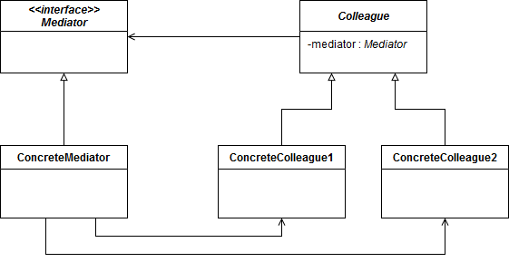

**Viva Questions:**

1. What is mediator Design Pattern?
2. What is Chain of responsibility?

1. What is the template method?
2. Explain the need of Mediator?
3. what is the need of Interpreter?

|  |  |  |  |  |  |  |  |  |  |  |
| --- | --- | --- | --- | --- | --- | --- | --- | --- | --- | --- |
| 0: Not Completed |  | 3: Late Complete/ In complete | | | | | |  | 6: Complete |  |
|  |  | | |  | | | | | | |
| Viva Voce |  | |  | |  |  |  | | | |
| **Signature of the Instructor** | | | | | | | | | | |

**Experiment 11: Date:____/____/20___**

**AIM:** Using UML design Proxy Design pattern

**Description:**

**Proxy:** Provide a surrogate or placeholder for another object to control access to it.

**Diagram:**

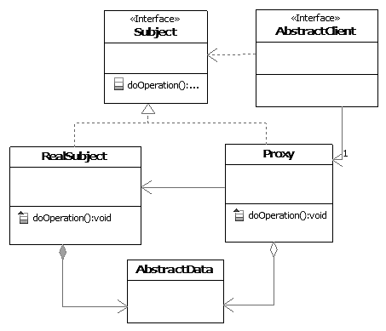

**AIM**: Using UML design Visitor Design pattern

**Description:**

**Visitor**: Represent an operation to be performed on the elements of an object structure. Visitor lets you define a new operation without changing the classes of the elements on which it operates.

**Diagram:**

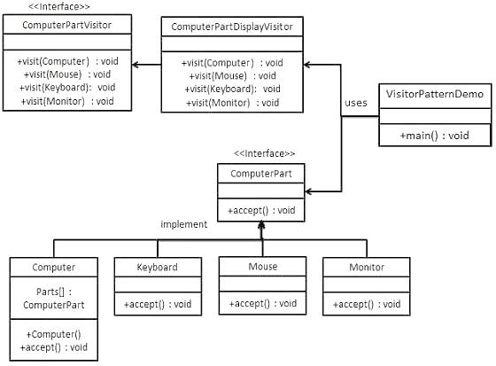

**Viva Questions:**

1. What is Proxy Design Pattern?
2. What is Visitor Design Pattern?
3. What is the need of Proxy Design Pattern?
4. Explain the need of Visitor?
5. What is Software Product Lines?

|  |  |  |  |  |  |  |  |  |  |  |
| --- | --- | --- | --- | --- | --- | --- | --- | --- | --- | --- |
| 0: Not Completed |  | 3: Late Complete/ In complete | | | | | |  | 6: Complete |  |
|  |  | | |  | | | | | | |
| Viva Voce |  | |  | |  |  |  | | | |
| **Signature of the Instructor** | | | | | | | | | | |